
Bahria University, Lahore Campus
Department of Computer Science
Lab Journal 07
(Fall 2025)

Course: | Introduction to Data Science - Lab | Date: _______________
Course Code: | CSL-487 | Max Marks: 20
Faculty’s Name: | Mr. Muhammad Umar Tariq

Name: Khawaja Fahad Zia Enroll No: 03-134221-057 Class: BSCS-6A

Objective(s):
Upon completion of this lab session, learners will be able to:
- Load and clean the data. Inspect structure, fix types, handle missing values, and remove duplicates.
- Explore and visualize key patterns. Identify features that influence churn and loan approval.
- Create and transform features. Encode categoricals and scale numeric variables for modeling.
- Train and evaluate models. Use logistic regression and random forest, and report accuracy, precision, recall, F1, and confusion matrix.
- Interpret results and recommend actions. Extract feature importances, explain business impact, and propose steps to reduce churn and improve approvals.

Lab Tasks:

Task 1: Customer Churn Prediction
Scenario:
You are working as a Junior Data Scientist at a telecom company named “ConnectX”.
The company is facing a growing issue of customer churn — customers leaving for competitor networks.
Management has provided you with a dataset ConnectX_Churn.csv containing details of 5,000 customers, including their demographics, account information, usage behavior, and whether they churned (1) or remained loyal (0).
Your task is to perform a complete end-to-end analysis using the concepts learned in previous Labs — focusing on data understanding, preprocessing, EDA, and classification model training.

Step-by-Step Instructions
Step 1: Data Loading and Initial Inspection
- Load the dataset into a DataFrame using appropriate pandas’ functions.
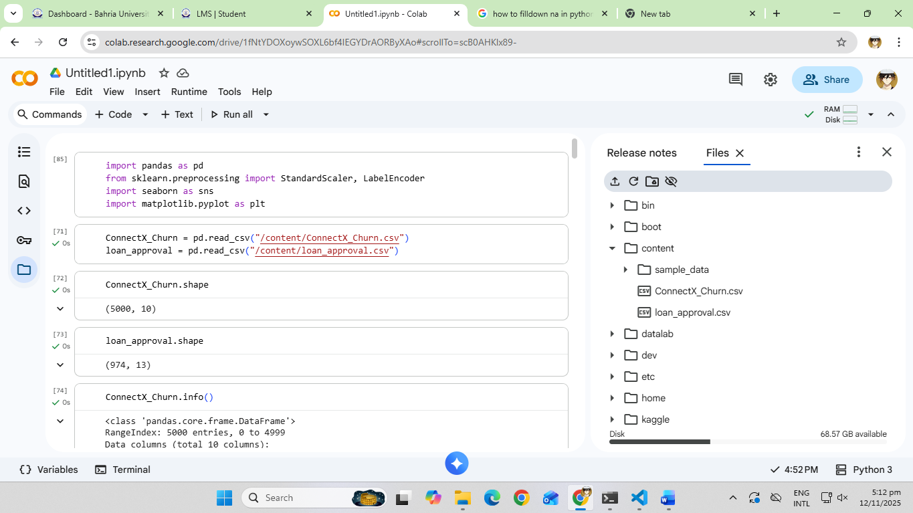
- View the first few records to understand structure and content.
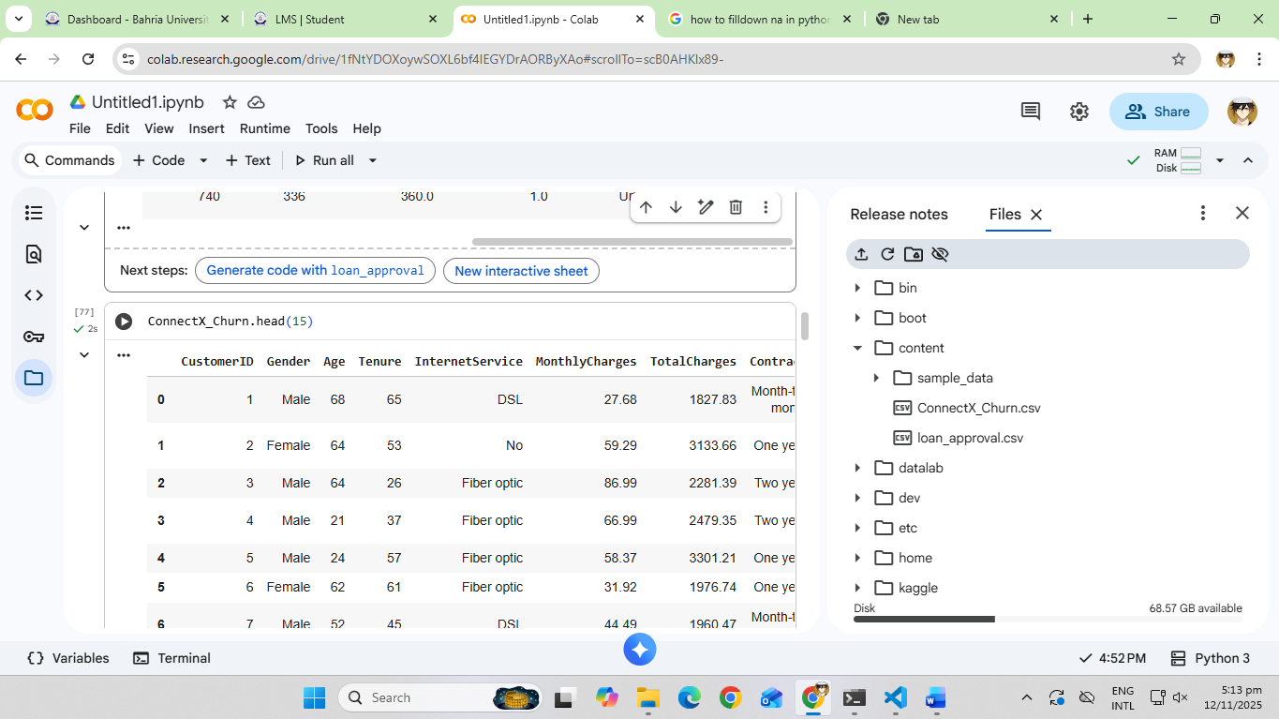
- Check shape, column names, data types, and detect missing values or duplicates.
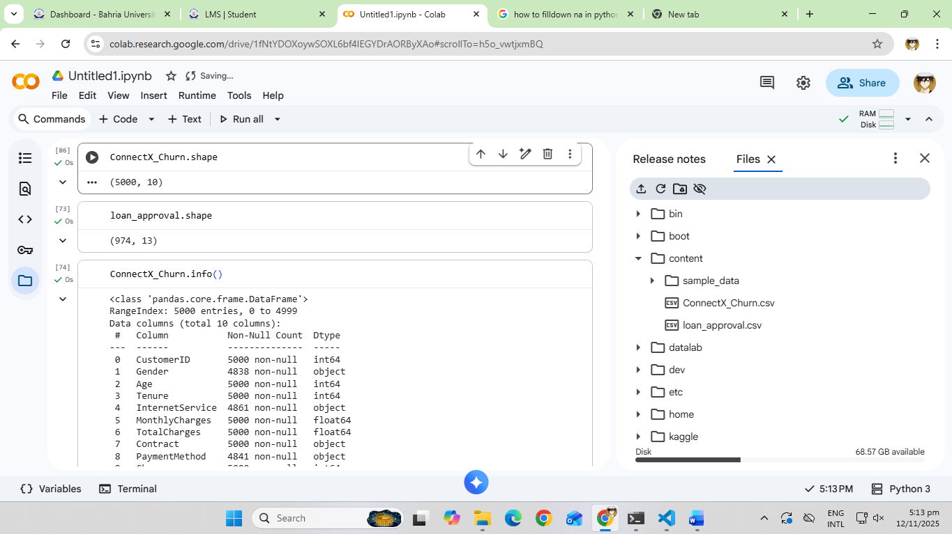
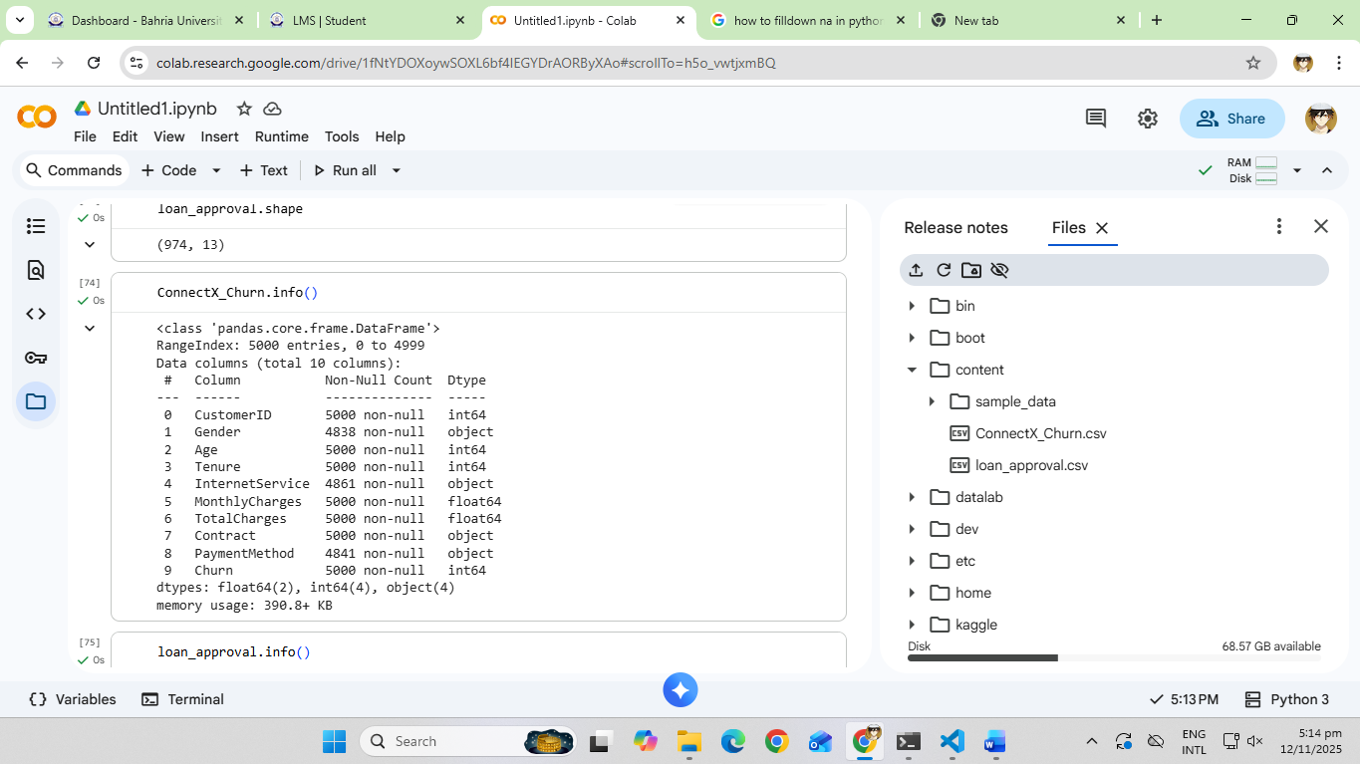
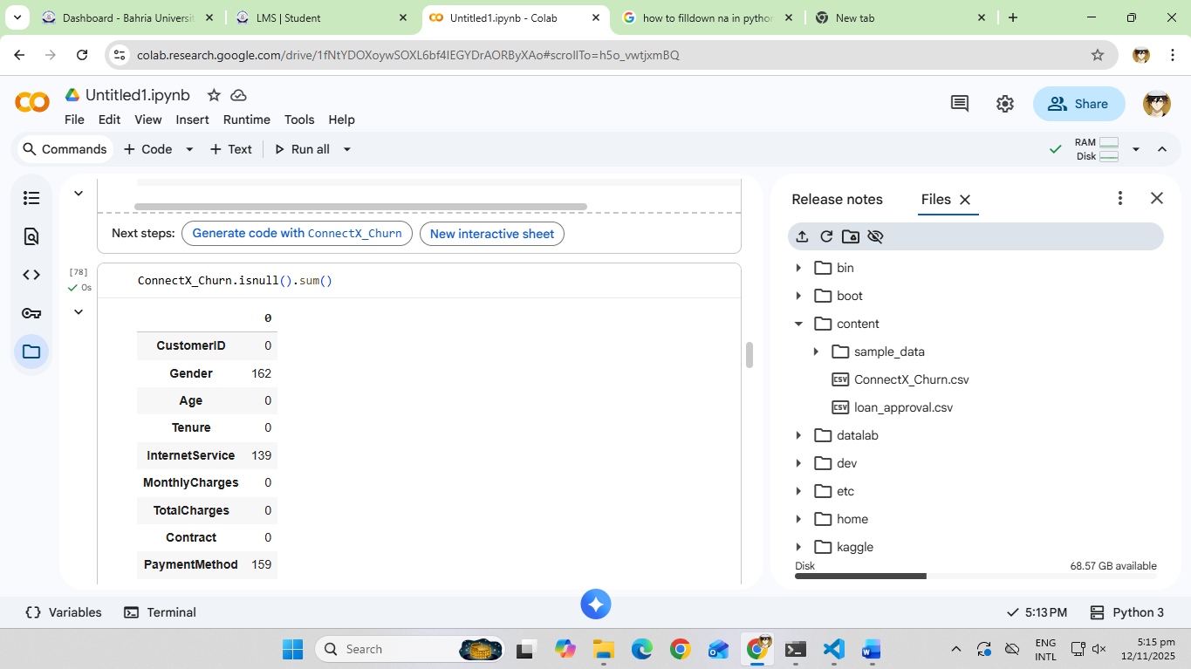

- Write short initial observations.
There are quite a few nulls in the dataset but there are no duplicates.

Step 2: Data Preprocessing
- Handle missing values:
  - Numeric → replace with mean or median.
No numeric are missing.
  - Categorical → replace with mode.
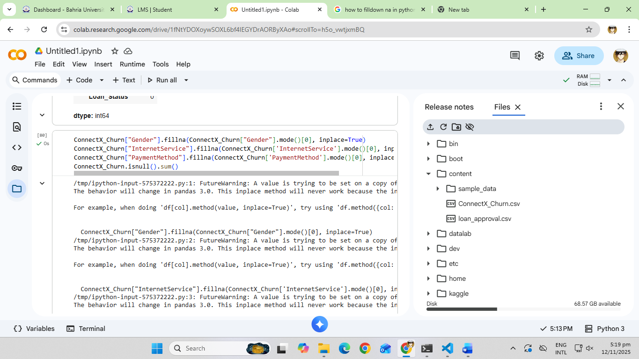
- Identify and remove duplicates.
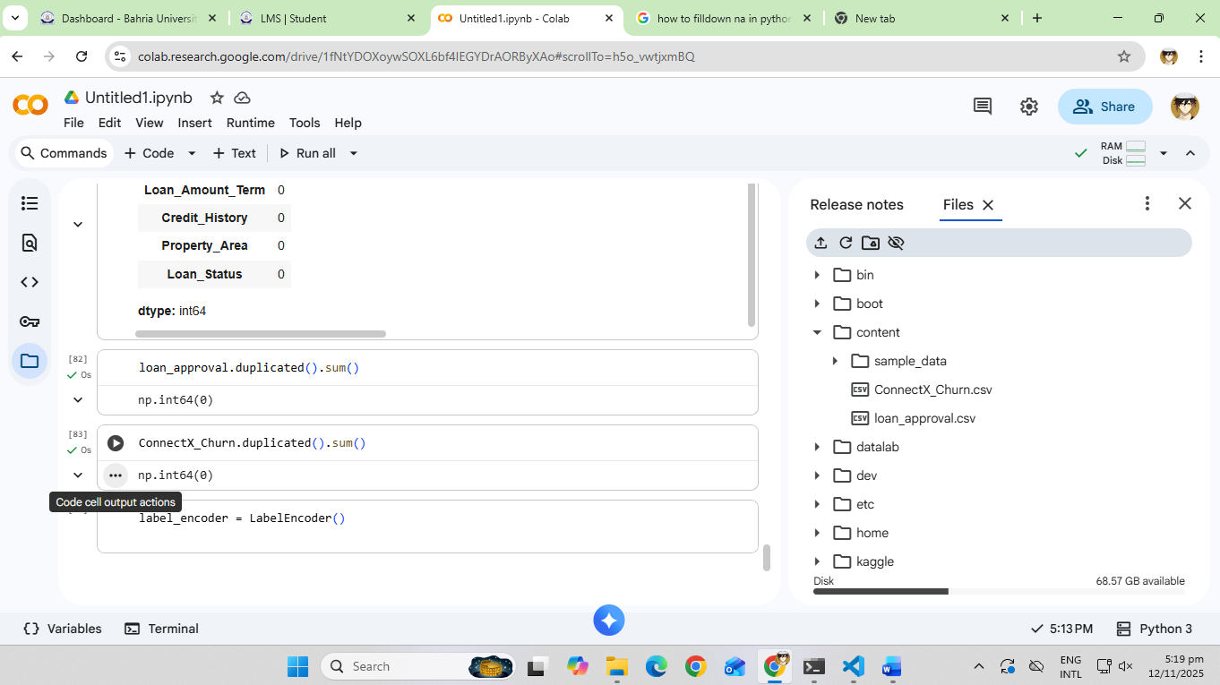
- Perform encoding for all categorical features (Label Encoding or One-Hot Encoding as appropriate).
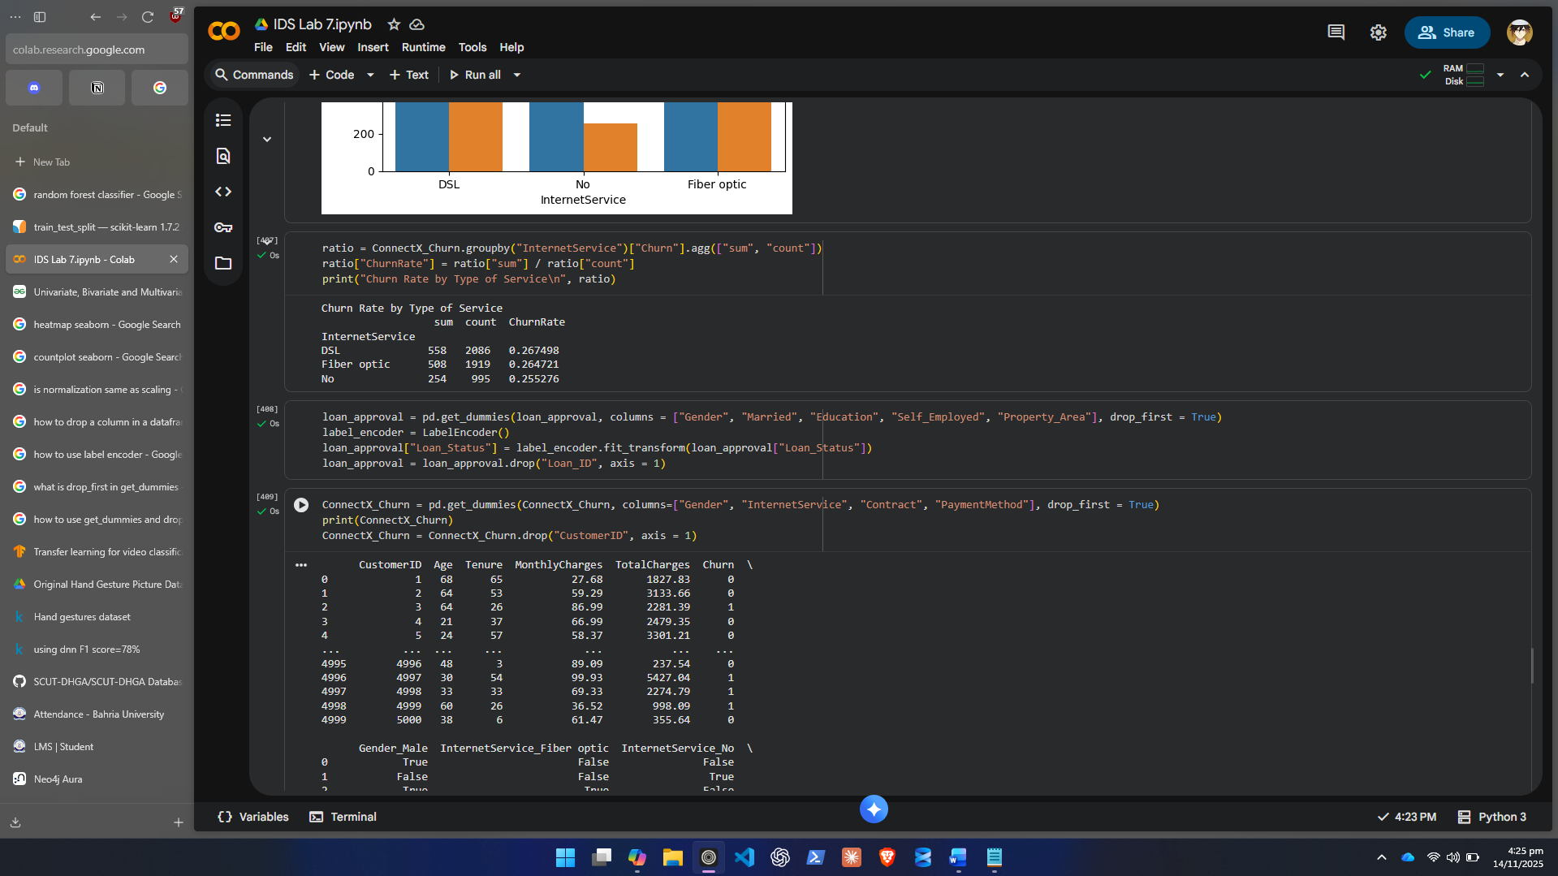
- Apply scaling or standardization to numeric columns to ensure equal importance in model training.
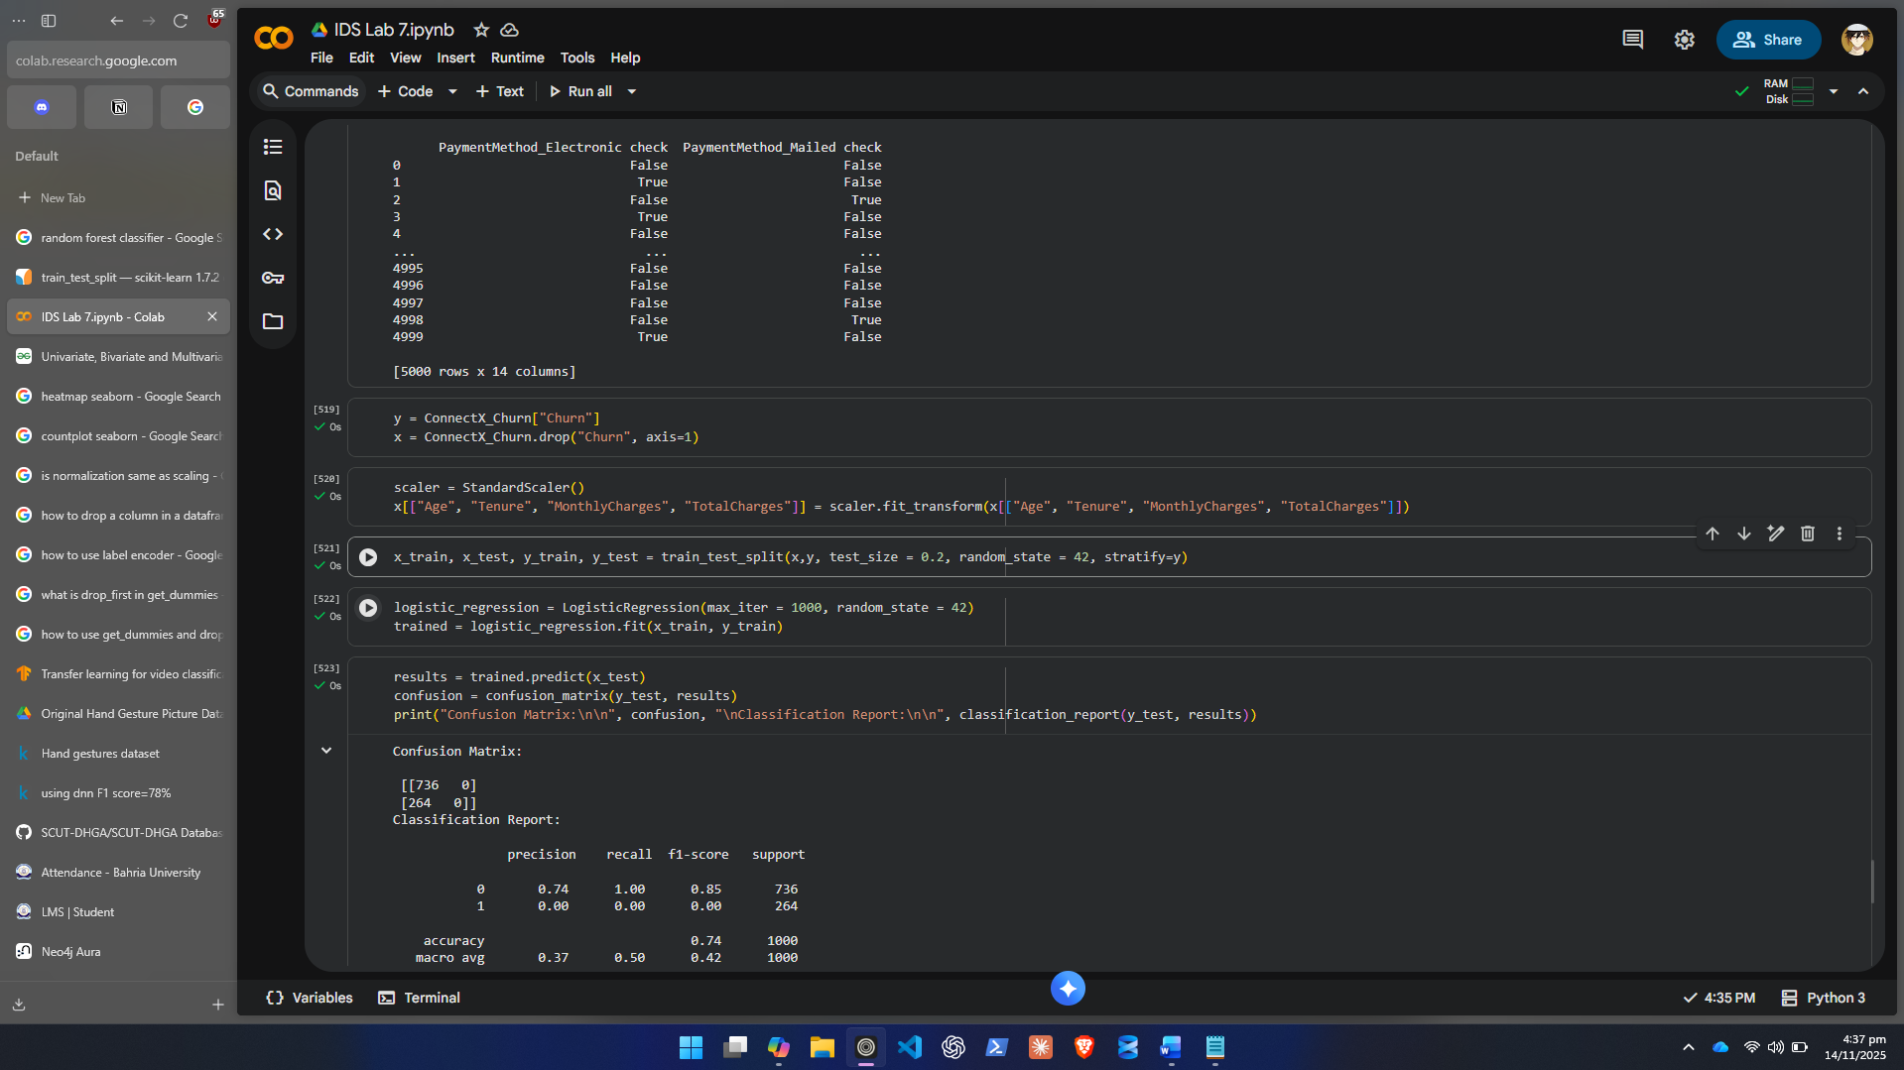
- Verify that no missing or inconsistent data remains.
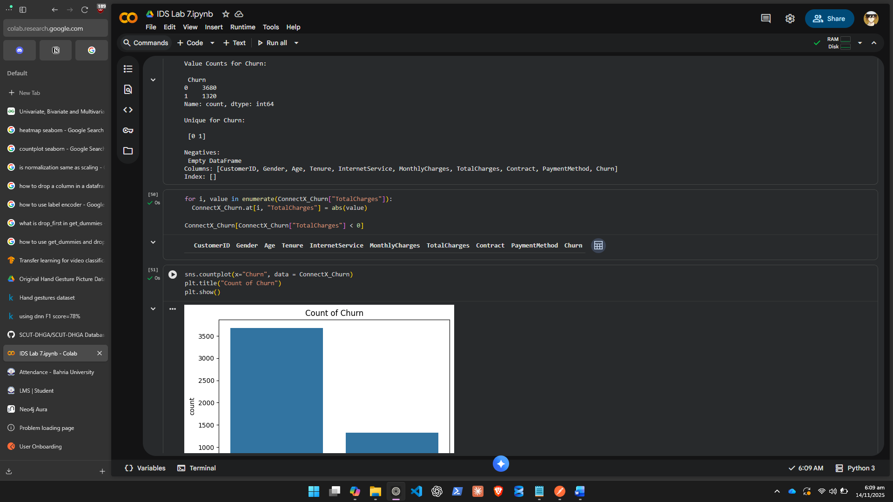

Step 3: Exploratory Data Analysis (EDA)
- Visualize the distribution of the target variable (Churn).
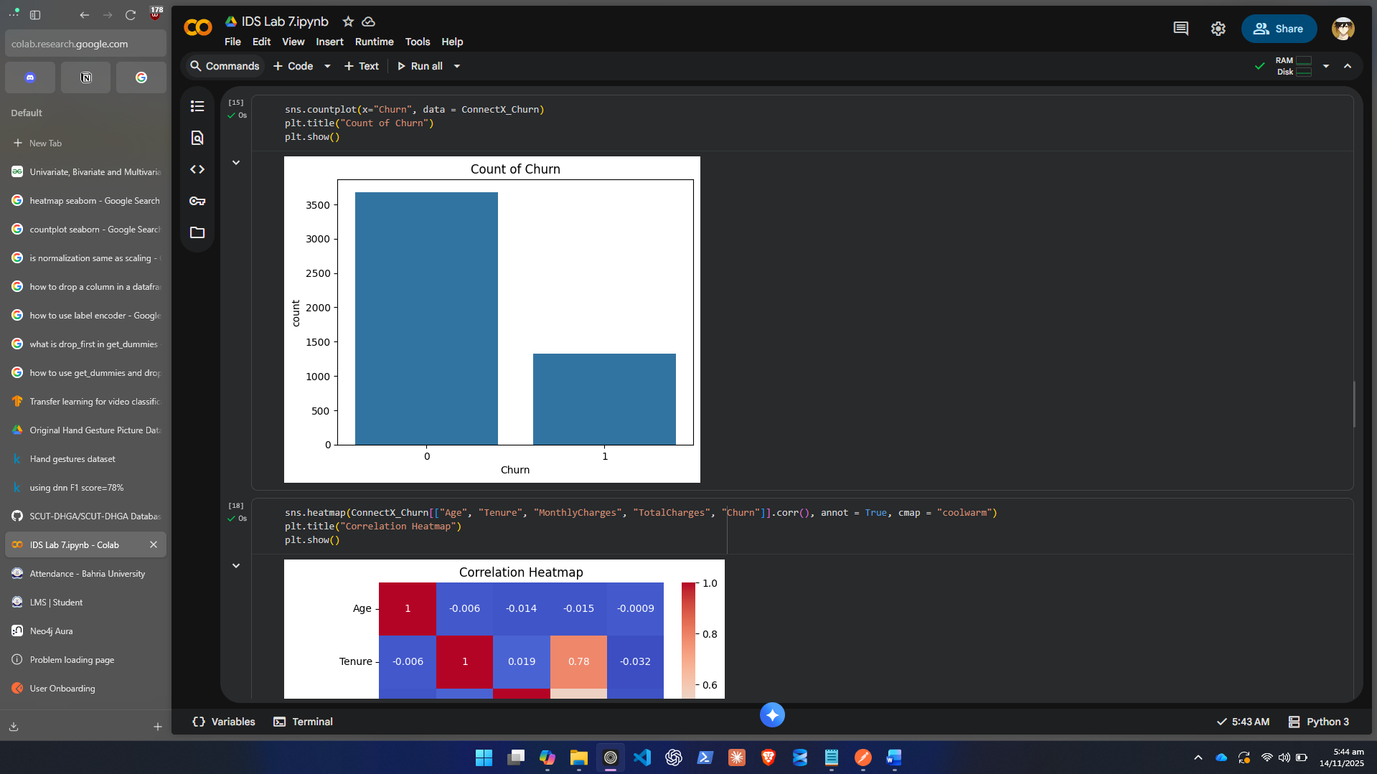
- Generate correlation heatmap to find numeric relationships.
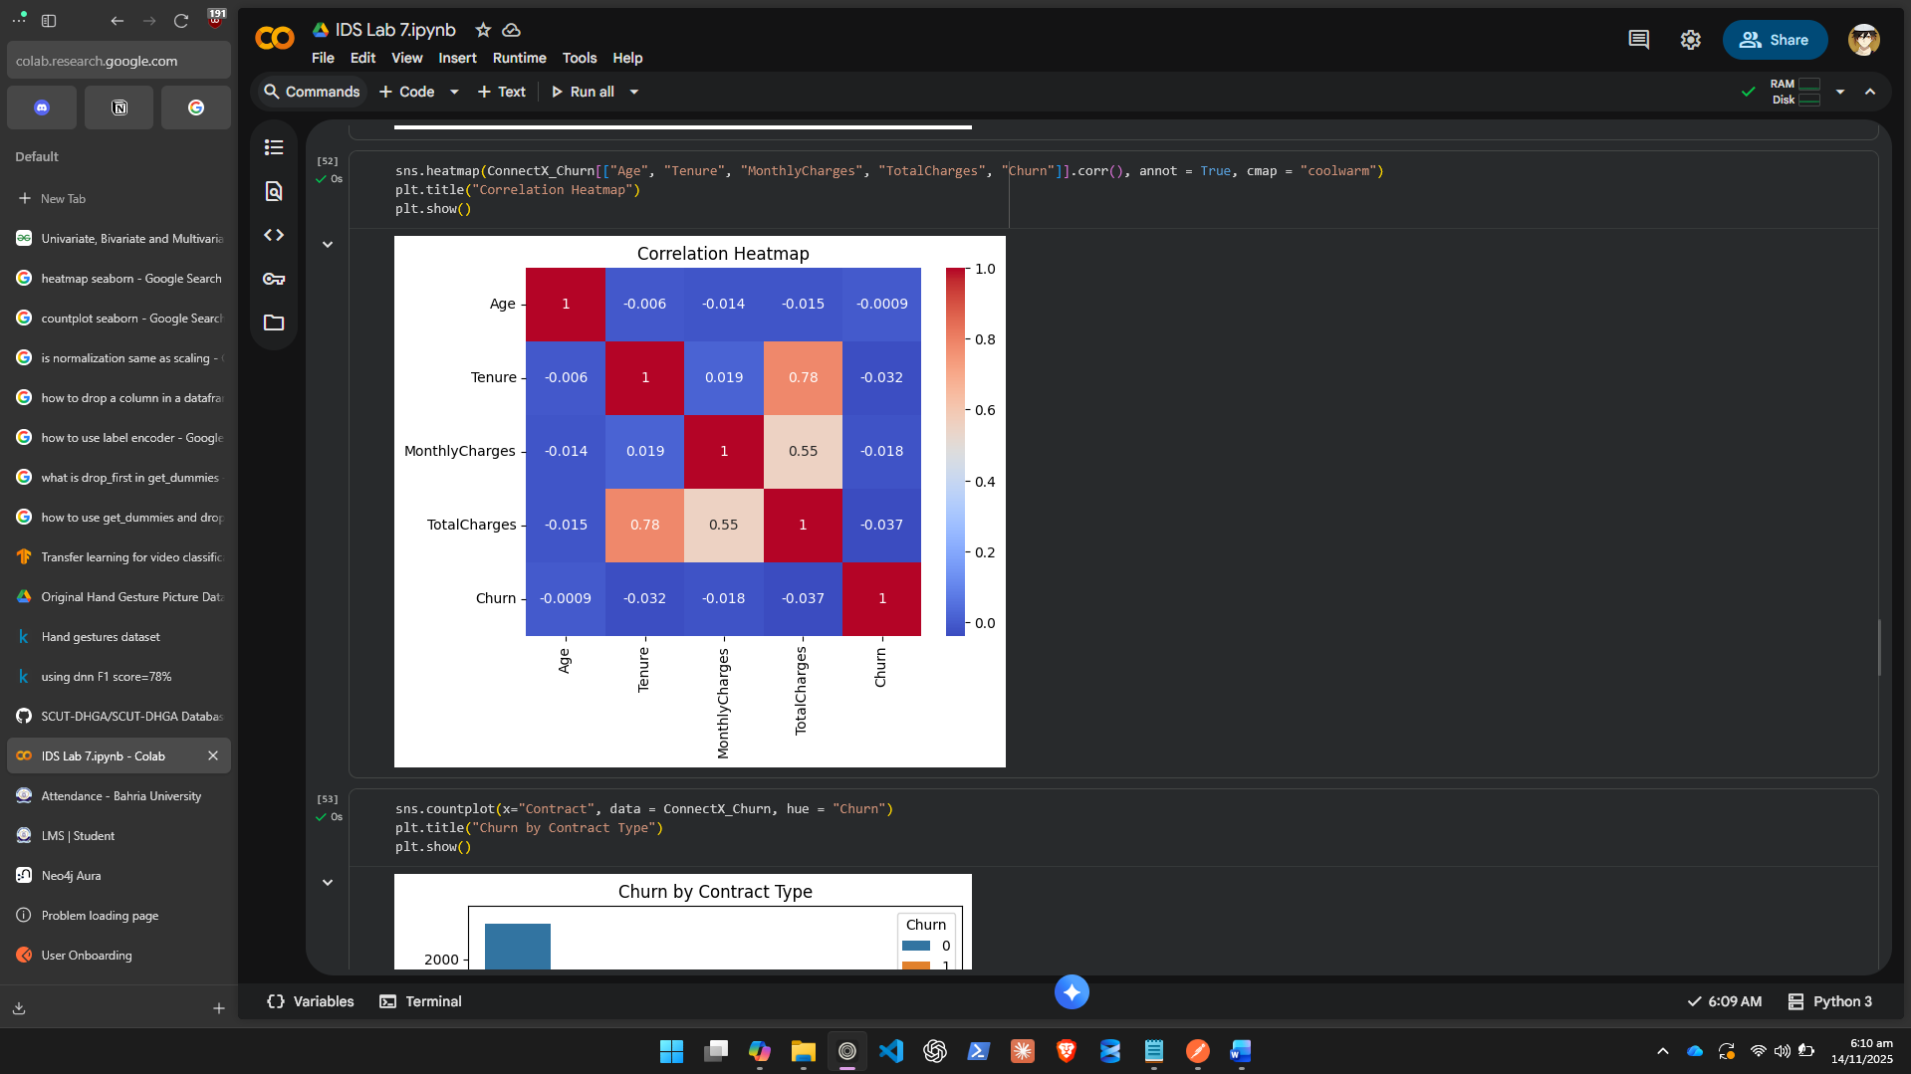
- Create countplots or boxplots to analyze relationships (e.g., Contract Type vs. Churn).
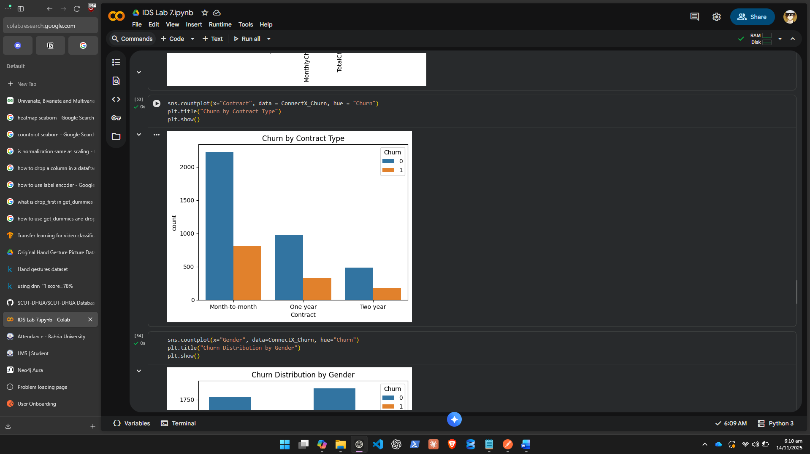
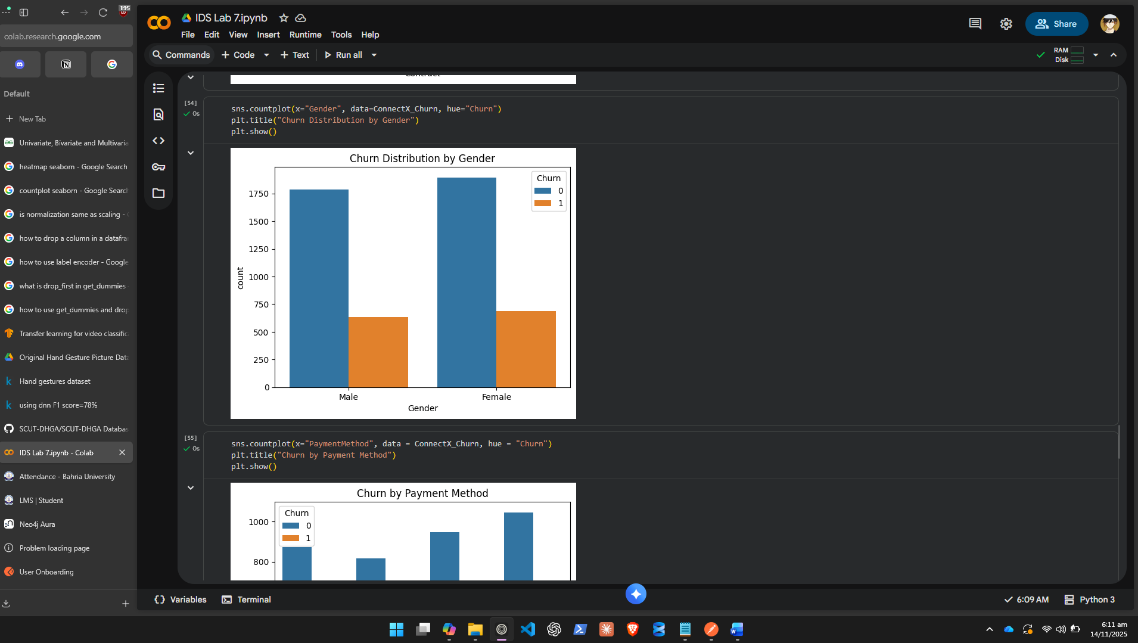
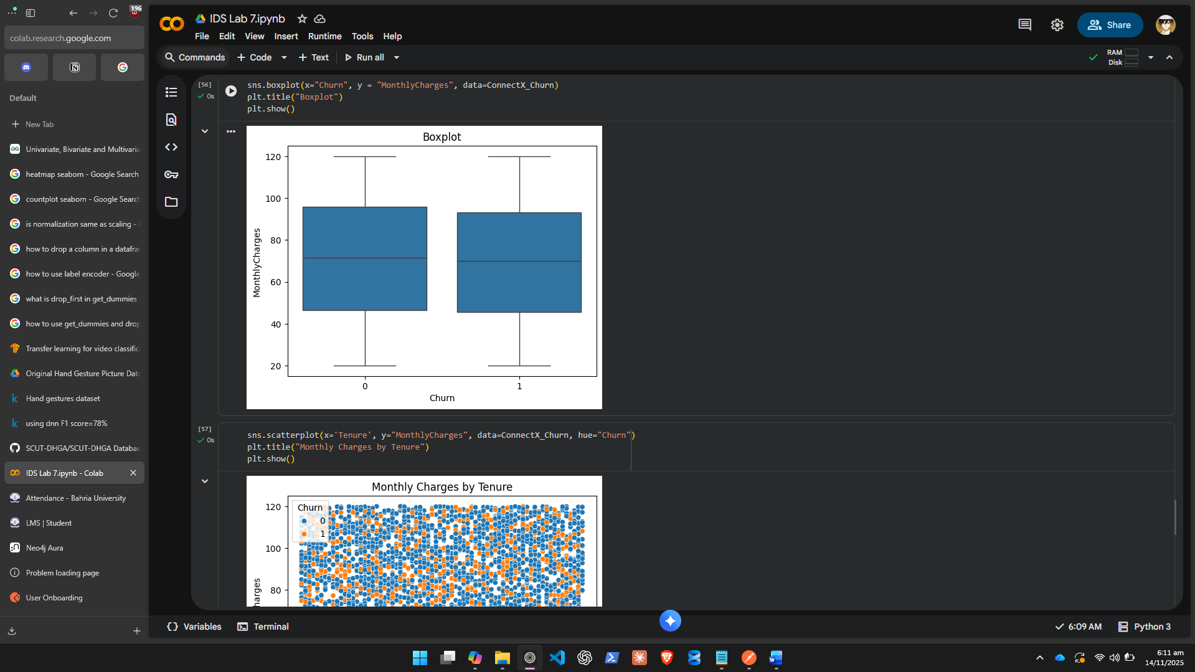
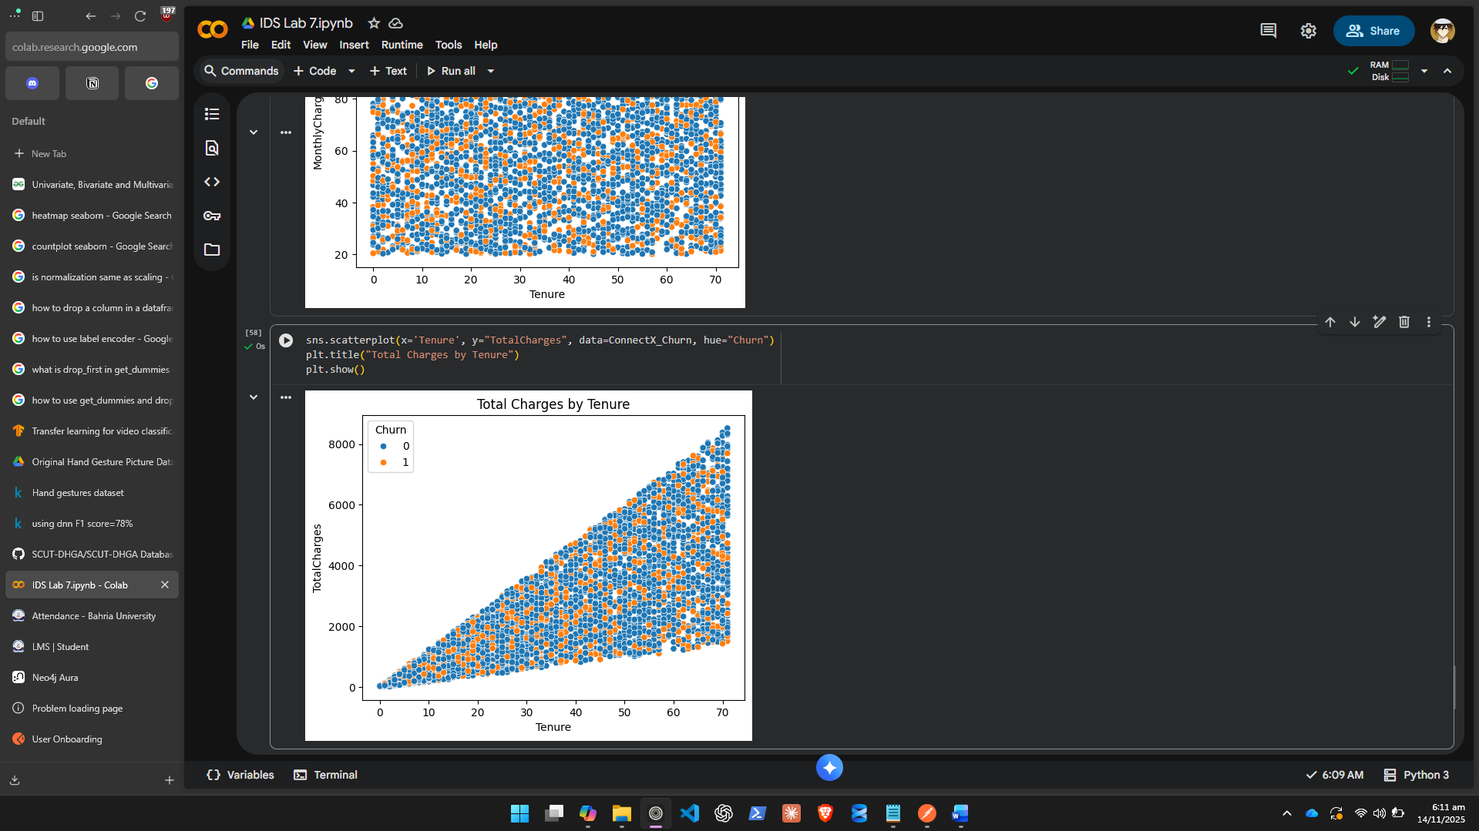
- Use scatterplots to explore interactions between numeric features.
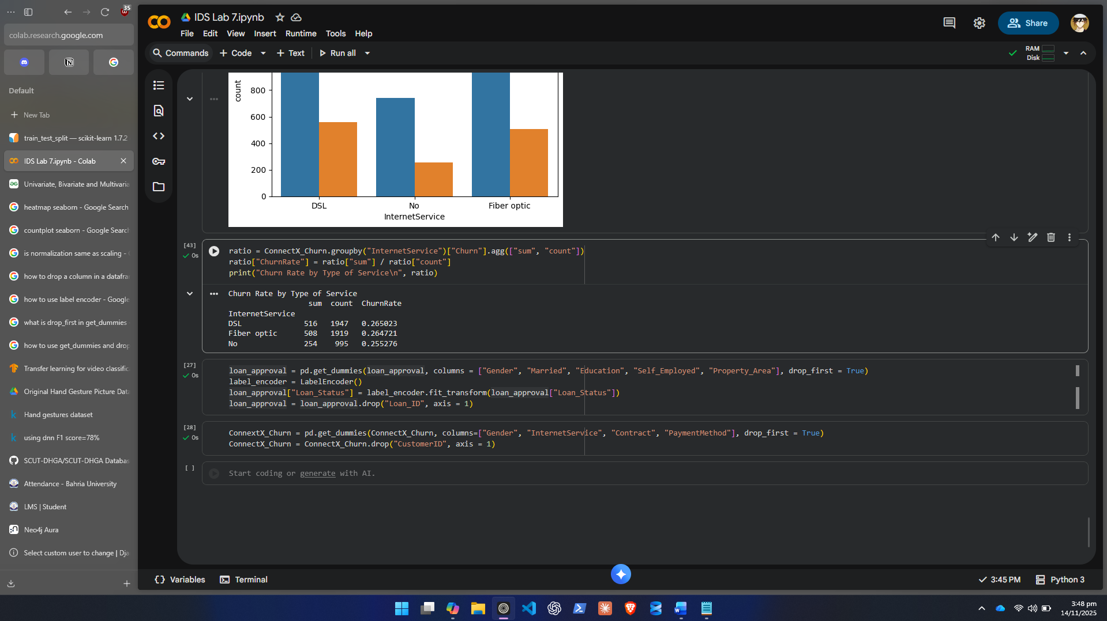
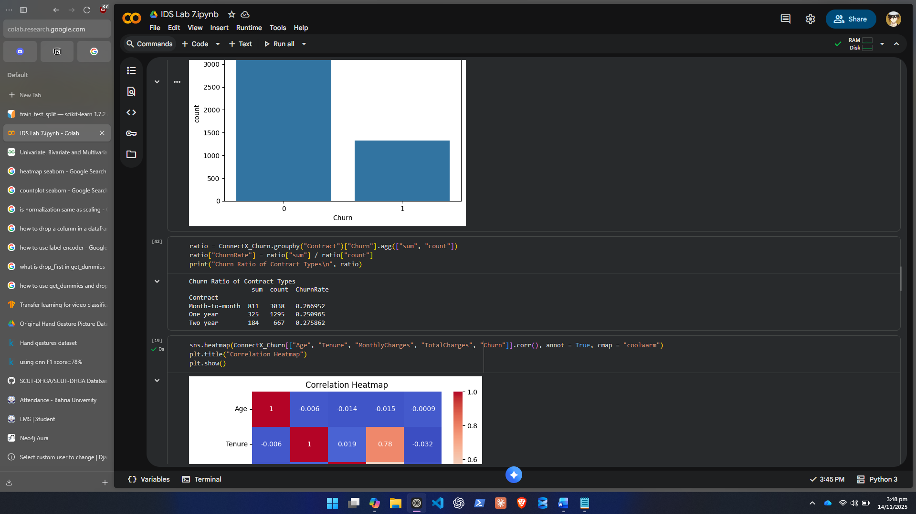
- Summarize findings — identify which factors most strongly influence churn (e.g., short contract, high monthly charge, fiber service).

There does not seem to be a strong relationship of fiber service, high monthly charge or length of contract. We can see the distributions of these metrics according to Churn Rate and they all have similar ratios for each type of occurrence. There are no obvious relationships with Churn and the Data seems to be unbalanced in terms of people who do not Churn.

Step 4: Data Splitting and Model Training
- Separate the dataset into:
  - X = features (all independent variables)
  - y = target (Churn)

- Apply train-test split (e.g., 80% train, 20% test).

- Train at least two models:
  - Logistic Regression
  - Random Forest Classifier

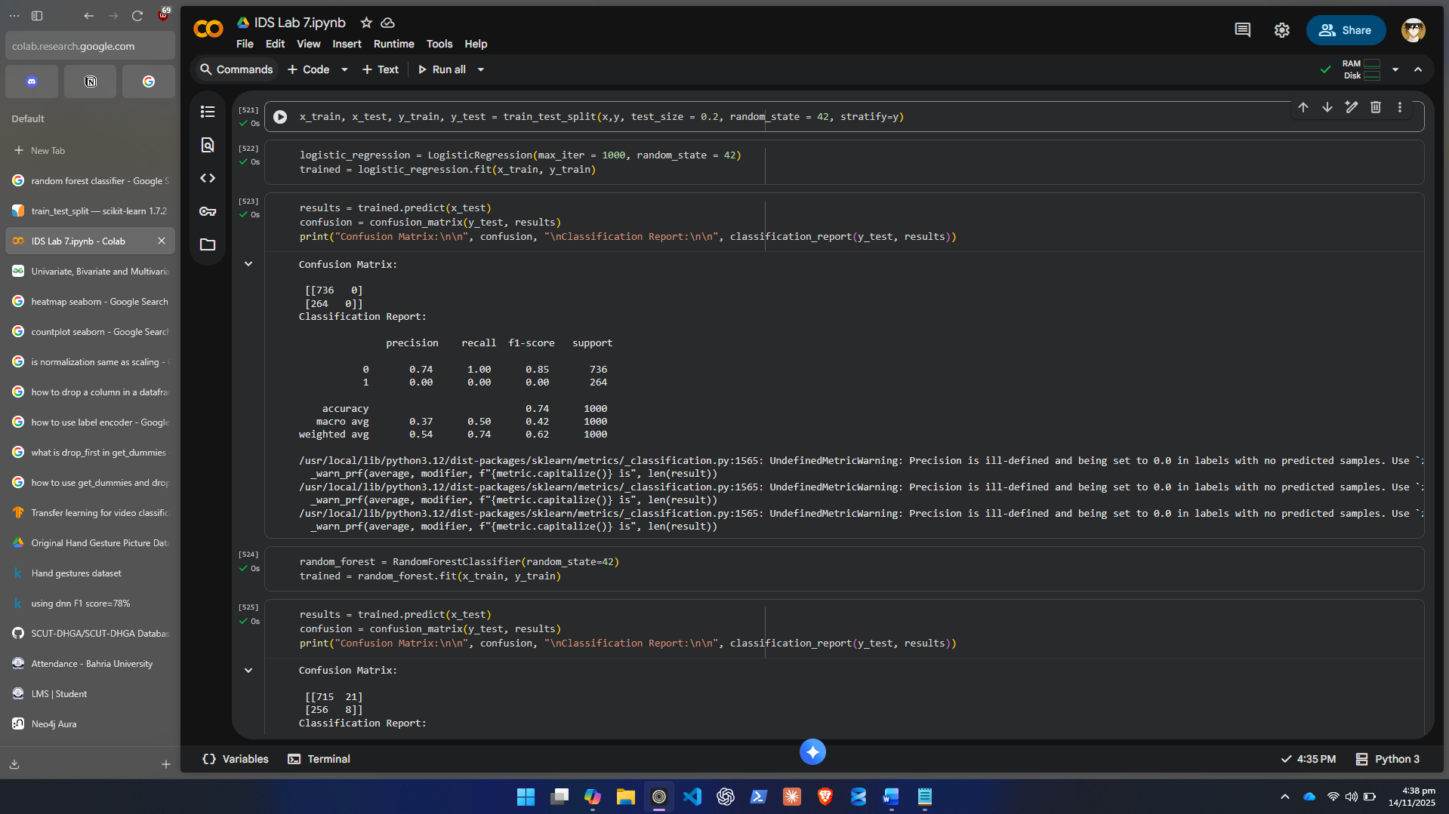
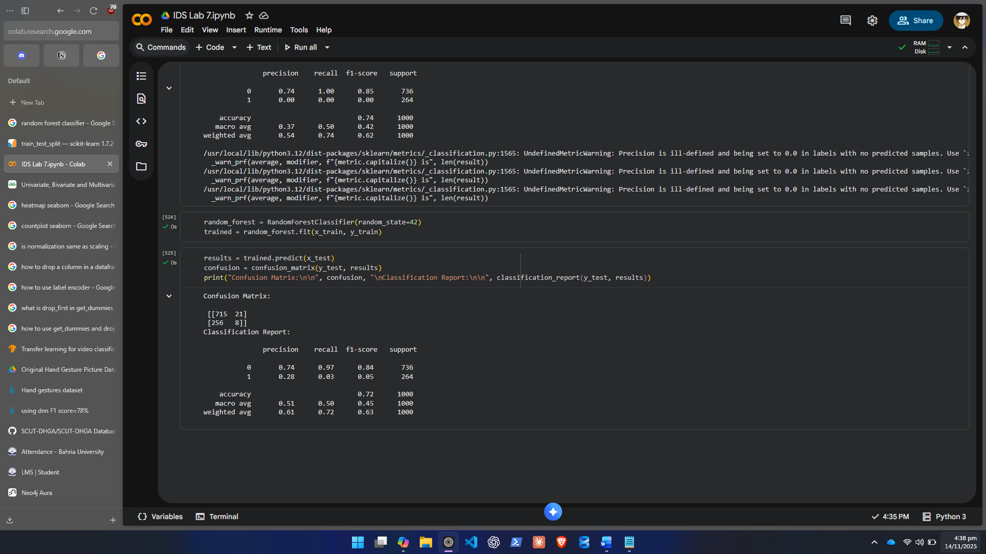
- Evaluate both models using:
  - Accuracy
  - Confusion Matrix
  - Classification Report (Precision, Recall, F1-Score)
Step 5: Comparison and Interpretation
- Create a small results table comparing model performance.
- Interpret which model performed better and why.
- Reflect on how data preprocessing affected the results.

 | Logistic Regression | Random Forest
Accuracy | 0.74 | 0.72
F1 Score 0 | 0.85 | 0.84
F1 Score 1 | 0 | 0.05

Random Forest Performed better but both results are horrendous on predicting 1s correctly.

Task 2: Customer Churn Prediction
Scenario
You are a Data Scientist working for a financial institution called SmartBank Ltd.
The bank receives hundreds of loan applications every day. To make faster and more accurate decisions, management wants to build an AI-based Loan Approval Prediction System that can automatically predict whether a loan should be Approved (Y) or Rejected (N) based on applicant information such as income, education, property area, and credit history.
Your task is to prepare, analyze, and model the given dataset to predict loan approval outcomes with at least 80% accuracy.
You must go through every step of the data science workflow — from data inspection to model evaluation — while also demonstrating your understanding of EDA, feature engineering, and evaluation metrics.

Step-by-Step Instructions
Step 1: Data Loading and Inspection
- Load the CSV file into your environment
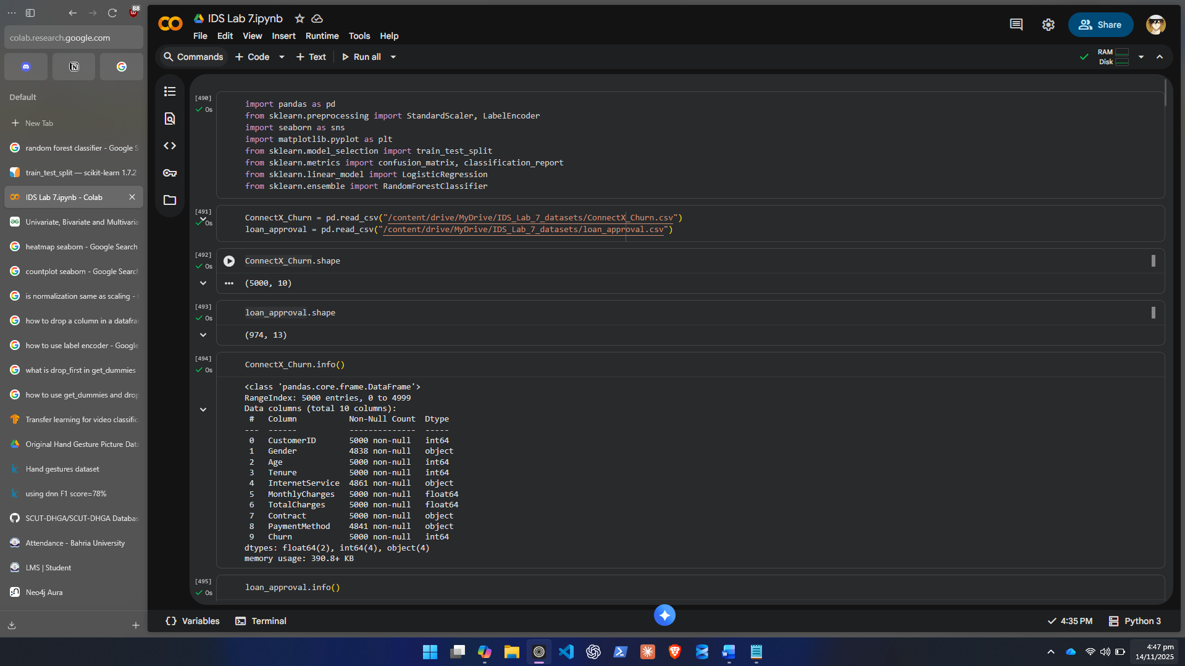
- View the first few rows to understand structure.
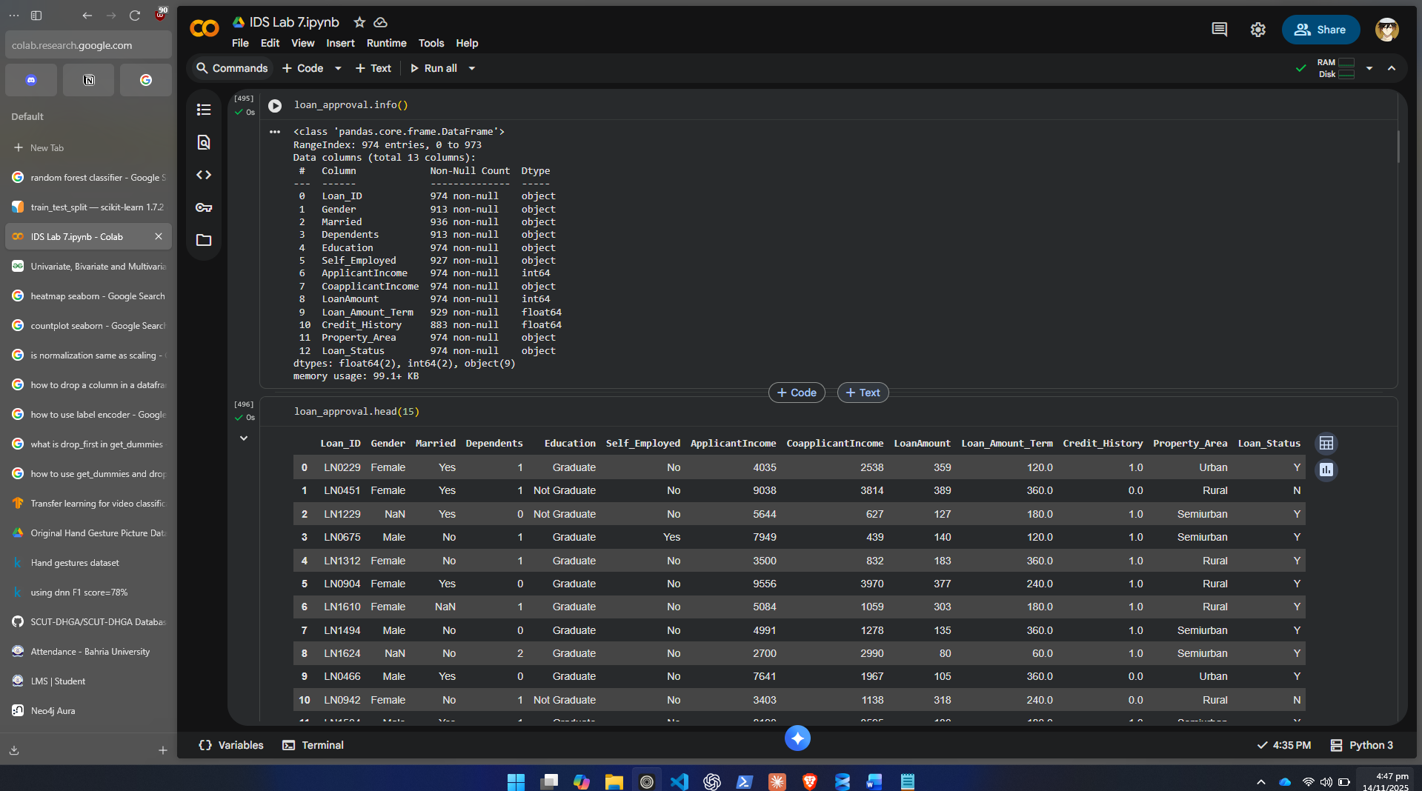
- Check:
  - Number of rows and columns
  - Data types of each column
  - Missing values
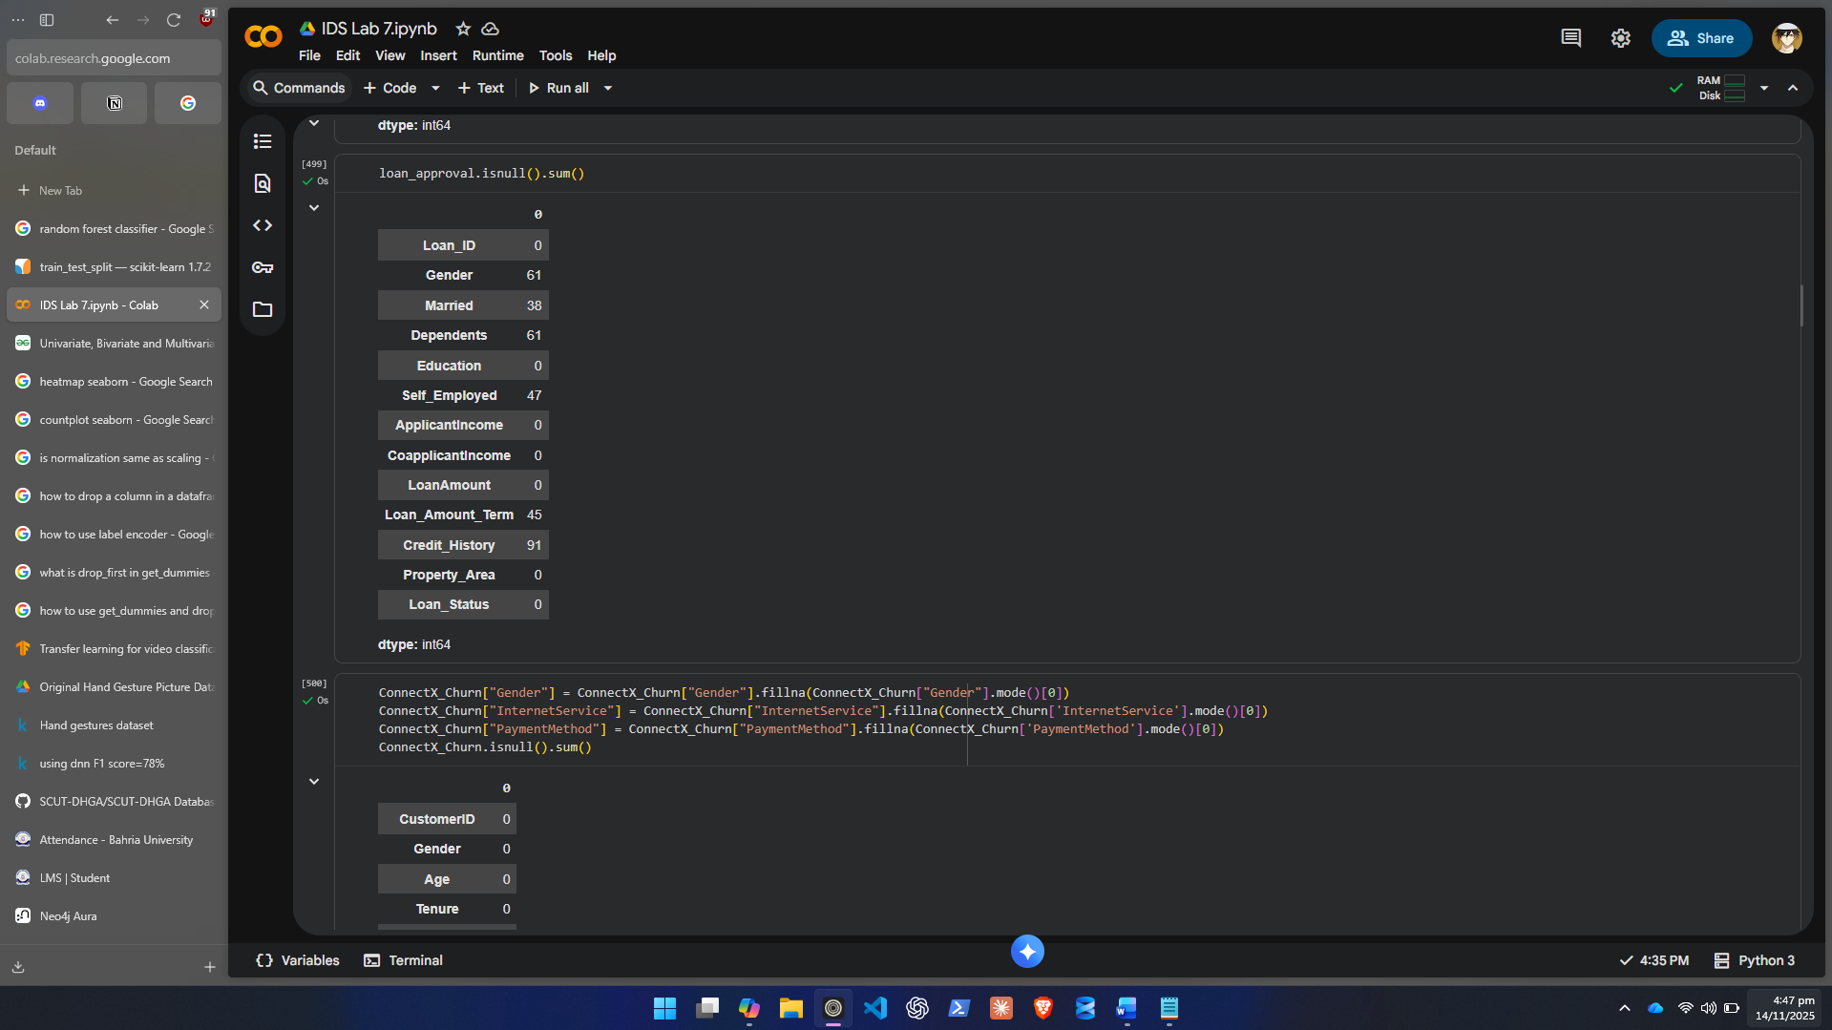
  - Presence of unusual values (e.g., “unknown”, negative numbers)
There are negatives in LoanAmount and “unknown” in Coapplicant income.

- Write short observations about what problems you see in the dataset.

Will have to remove null values, fix negative values, do label and one-hot encoding and change type of Coapplicant income to float type after removing unknowns.

Step 2: Data Preprocessing
- Fix incorrect data types (convert text-based numeric columns).
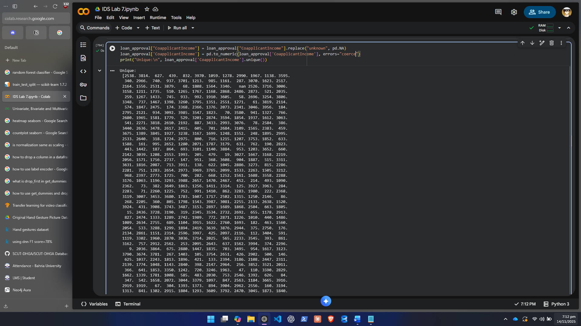
- Handle invalid or missing values:
  - Numerical columns → replace missing with median
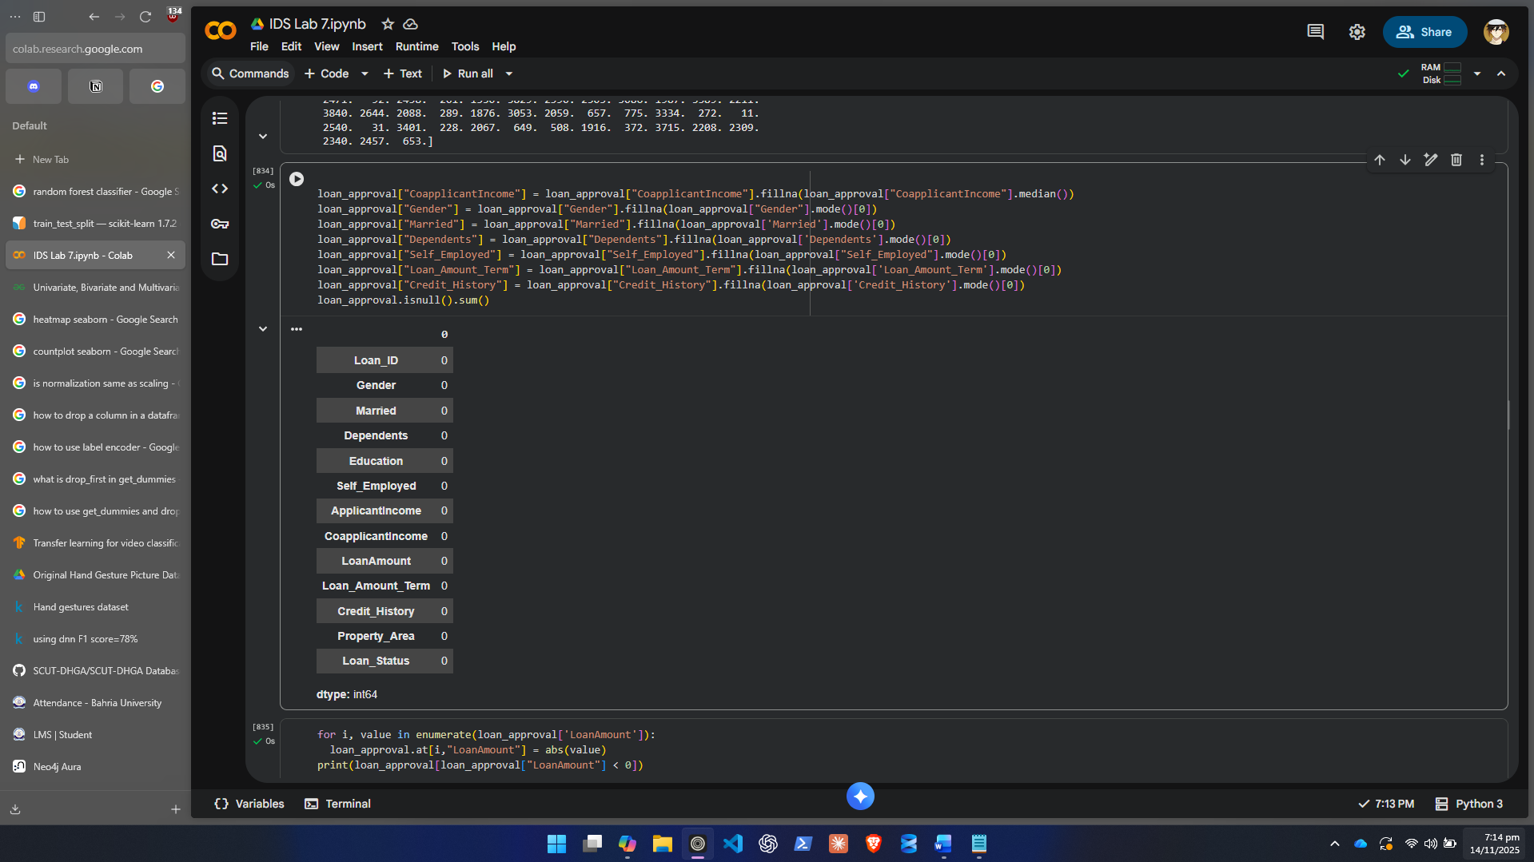
  - Categorical columns → replace missing with mode
- Correct any negative or inconsistent values.
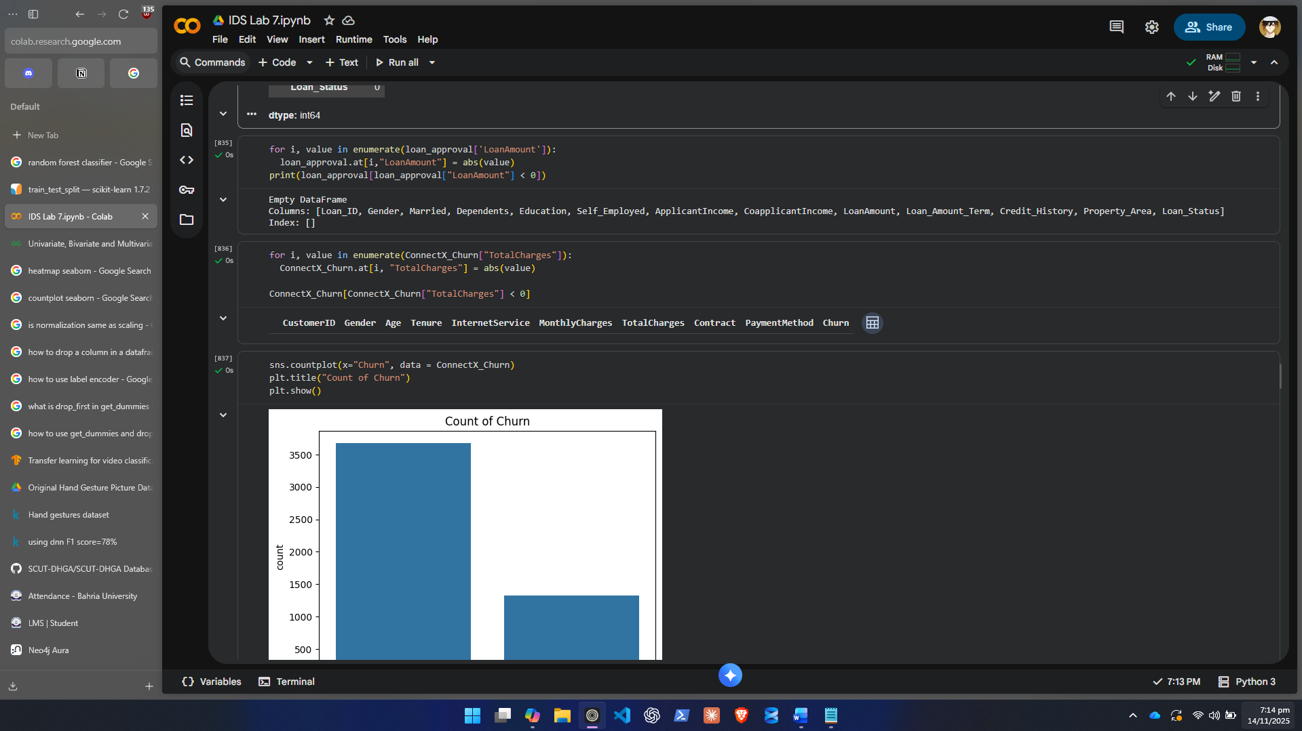
- Re-check the dataset to ensure no missing values remain.
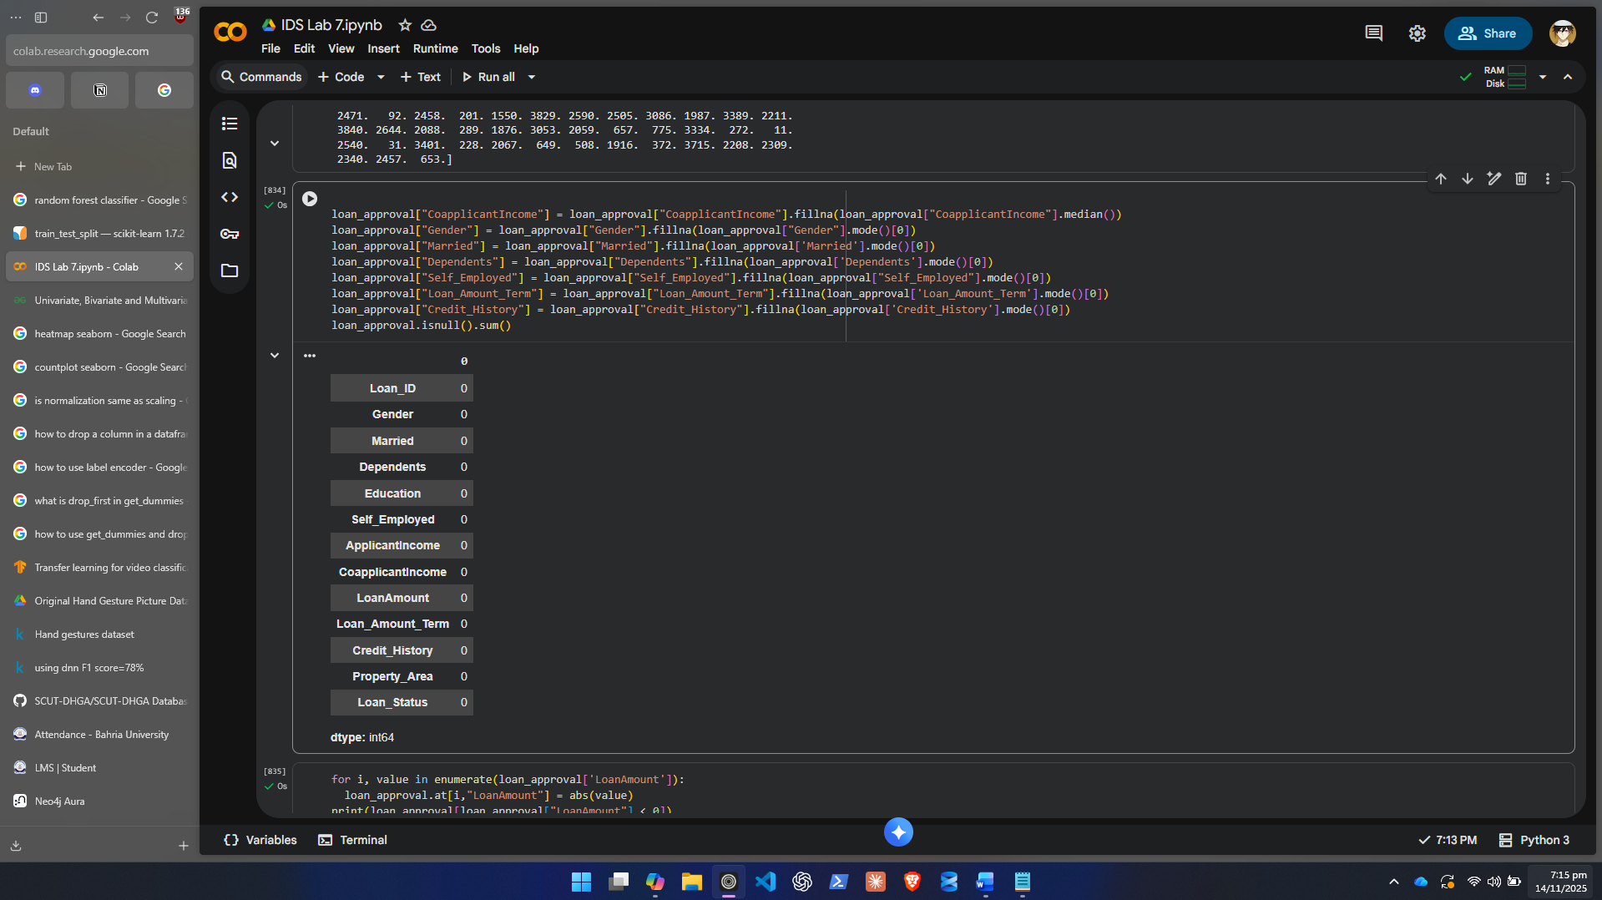
- Document all preprocessing steps and justify why you applied them.
In cleaning erroneous values had to be fixed in order to apply any kind of transformations. The values with wrong data types had to be converted to correct ones. We did no integration.

Step 3: Exploratory Data Analysis (EDA)
- Explore numeric feature distributions (e.g., ApplicantIncome, LoanAmount).
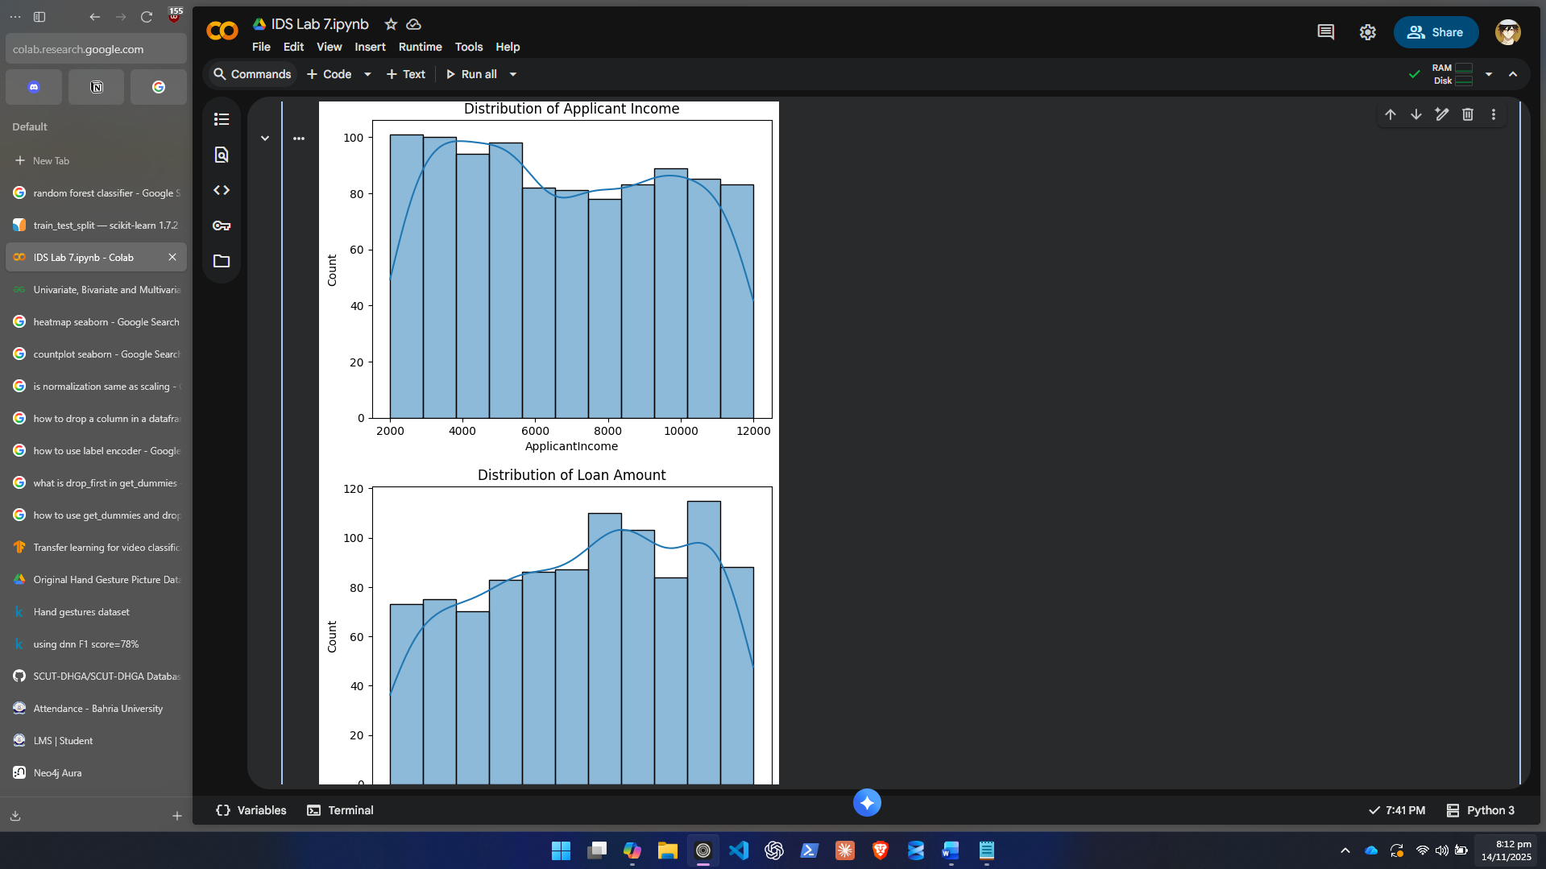
- Explore categorical features (e.g., Gender, Education, Property_Area).

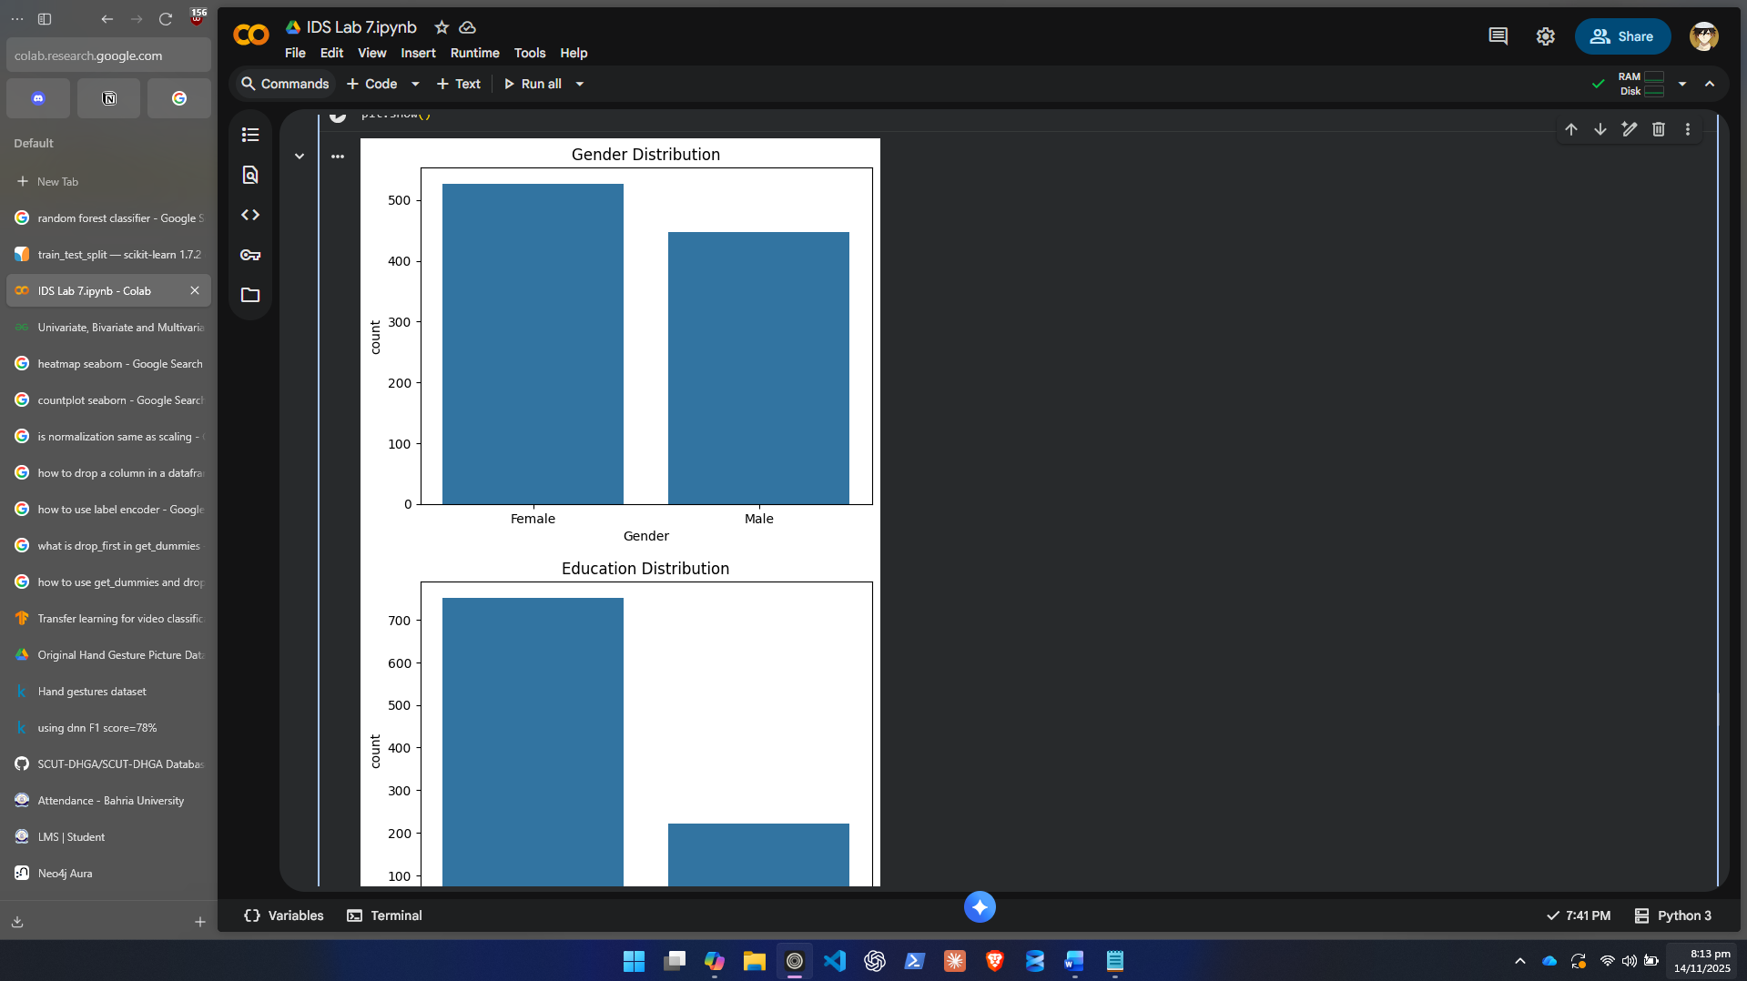
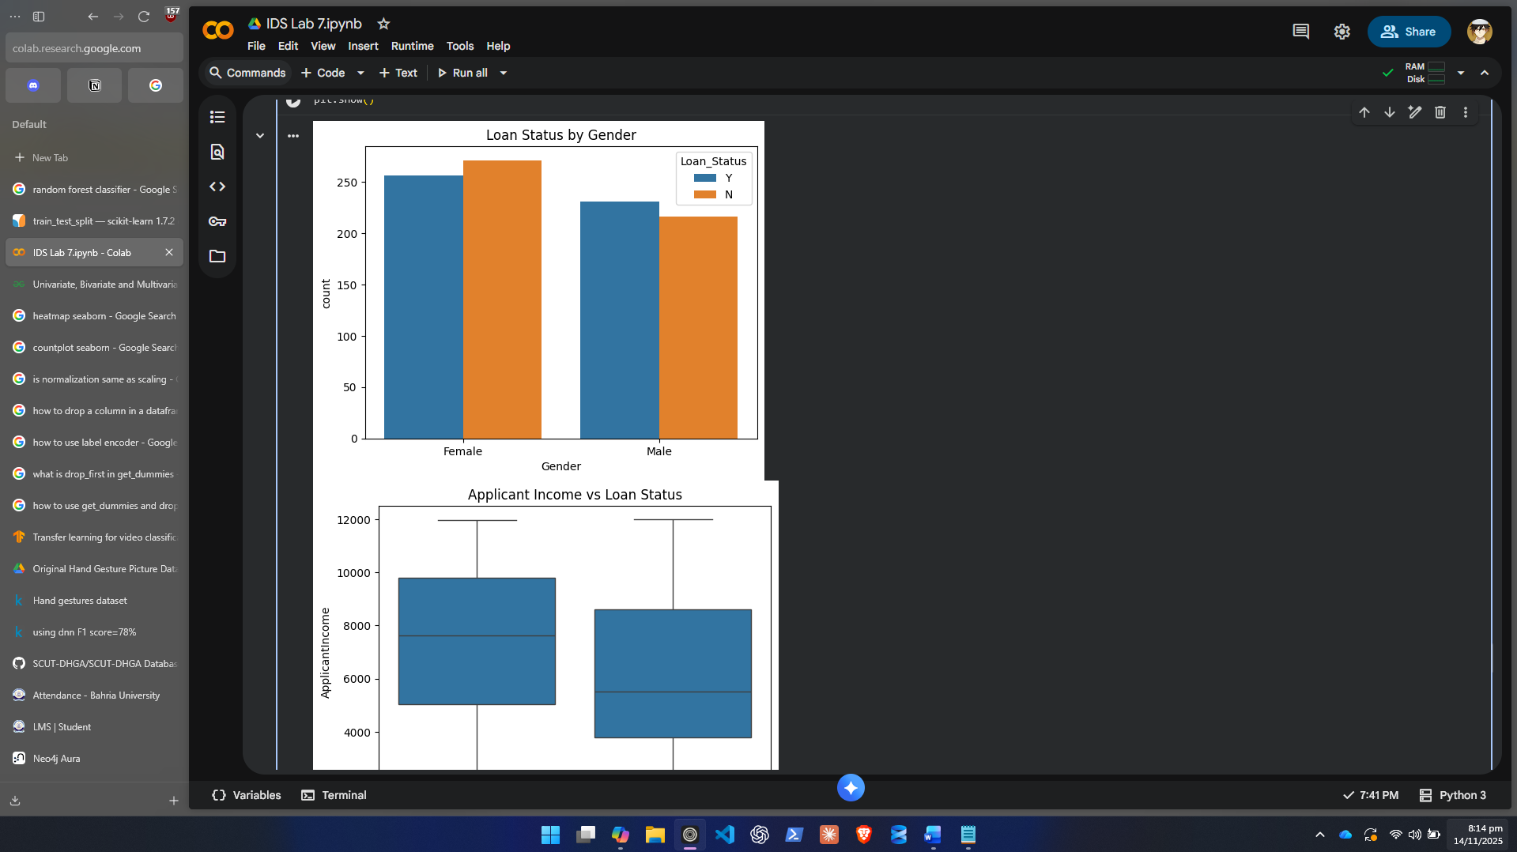
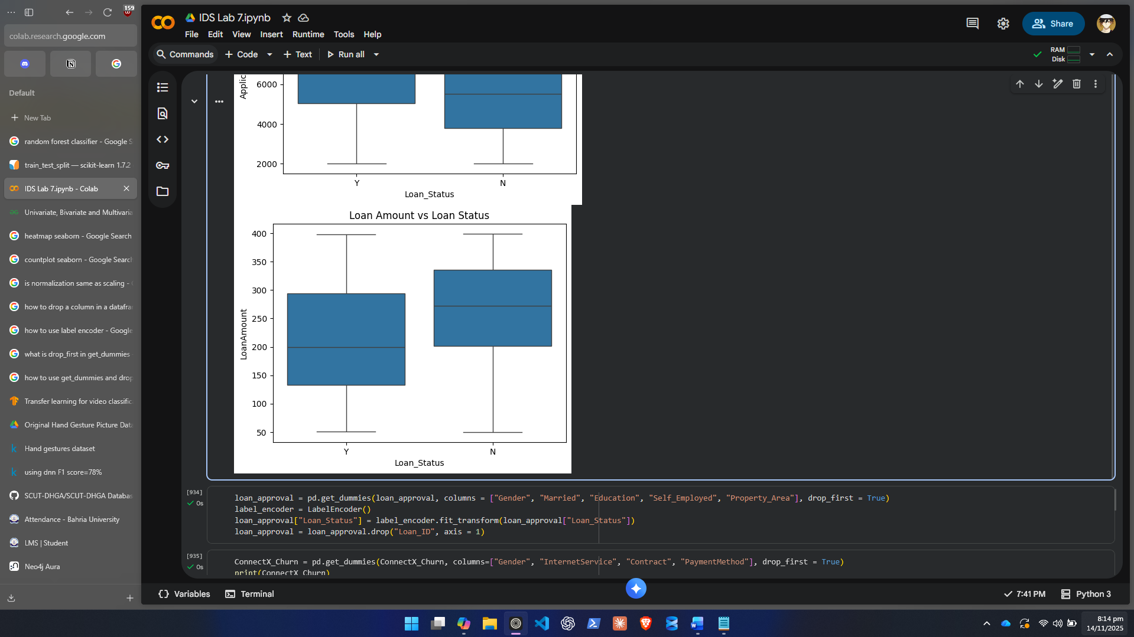
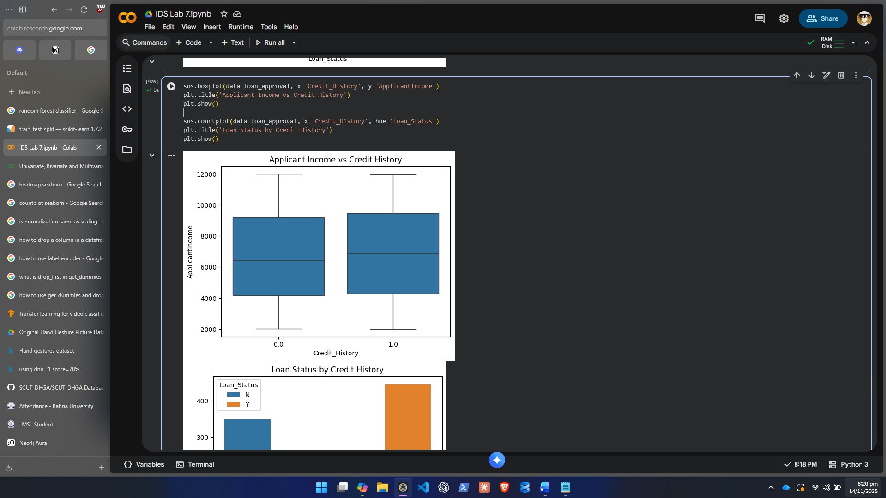
- Study relationships:
  - Which factors differ between approved and rejected loans?
People with lower loan amounts get more of them accepted usually. Its easier for people with higher incomes to get loans approved. There isn’t much of an effect from Gender for loan approval. Graduates and females apply for loans more.
  - Does income or credit history seem more important?
Vastly more people get their loans approved who have better credit history than the difference between lower and higher incomes as a lot of the area in the box plot overlaps in the income ranges.

- Visualize insights using charts (histograms, count plots, and heatmaps).

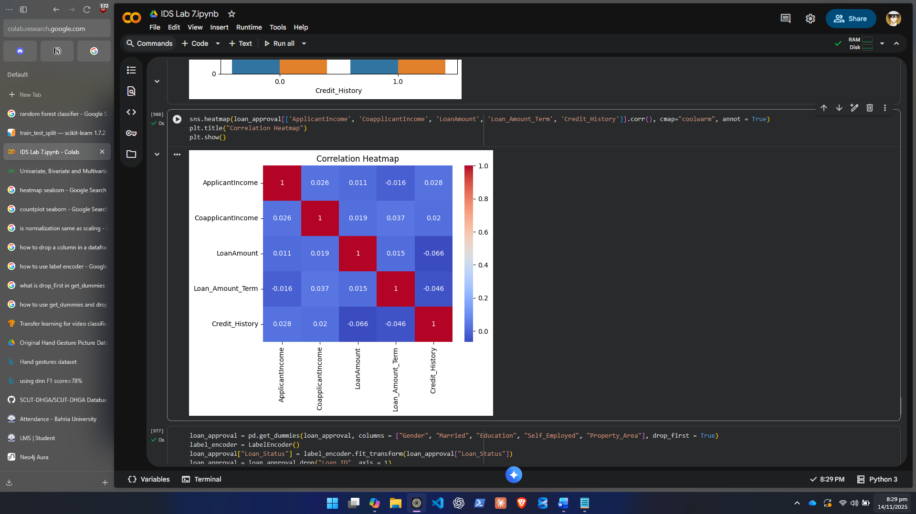
- Summarize your EDA findings in bullet points (at least 5 key insights).

- People with lower loan amounts get more of them accepted usually.
- Its easier for people with higher incomes to get loans approved.
- There isn’t much of an effect from Gender for loan approval.
- Graduates and females apply for loans more.
- Vastly more people get their loans approved who have better credit history than the difference between lower and higher incomes as a lot of the area in the box plot overlaps in the income ranges.

Step 4: Feature Engineering
- Convert or Create Features:
  - Create TotalIncome = ApplicantIncome + CoapplicantIncome.
  - Create Income_to_Loan_Ratio = TotalIncome / LoanAmount.
  - Create Family_Size = Dependents + 1.
  - Apply log transformation to LoanAmount to handle skewness.

- Encode categorical columns using label or one-hot encoding.
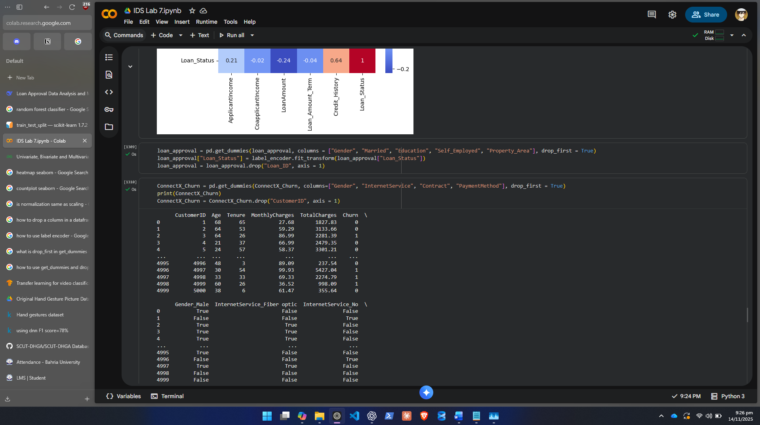

- Scale numeric columns to standardize the feature range.

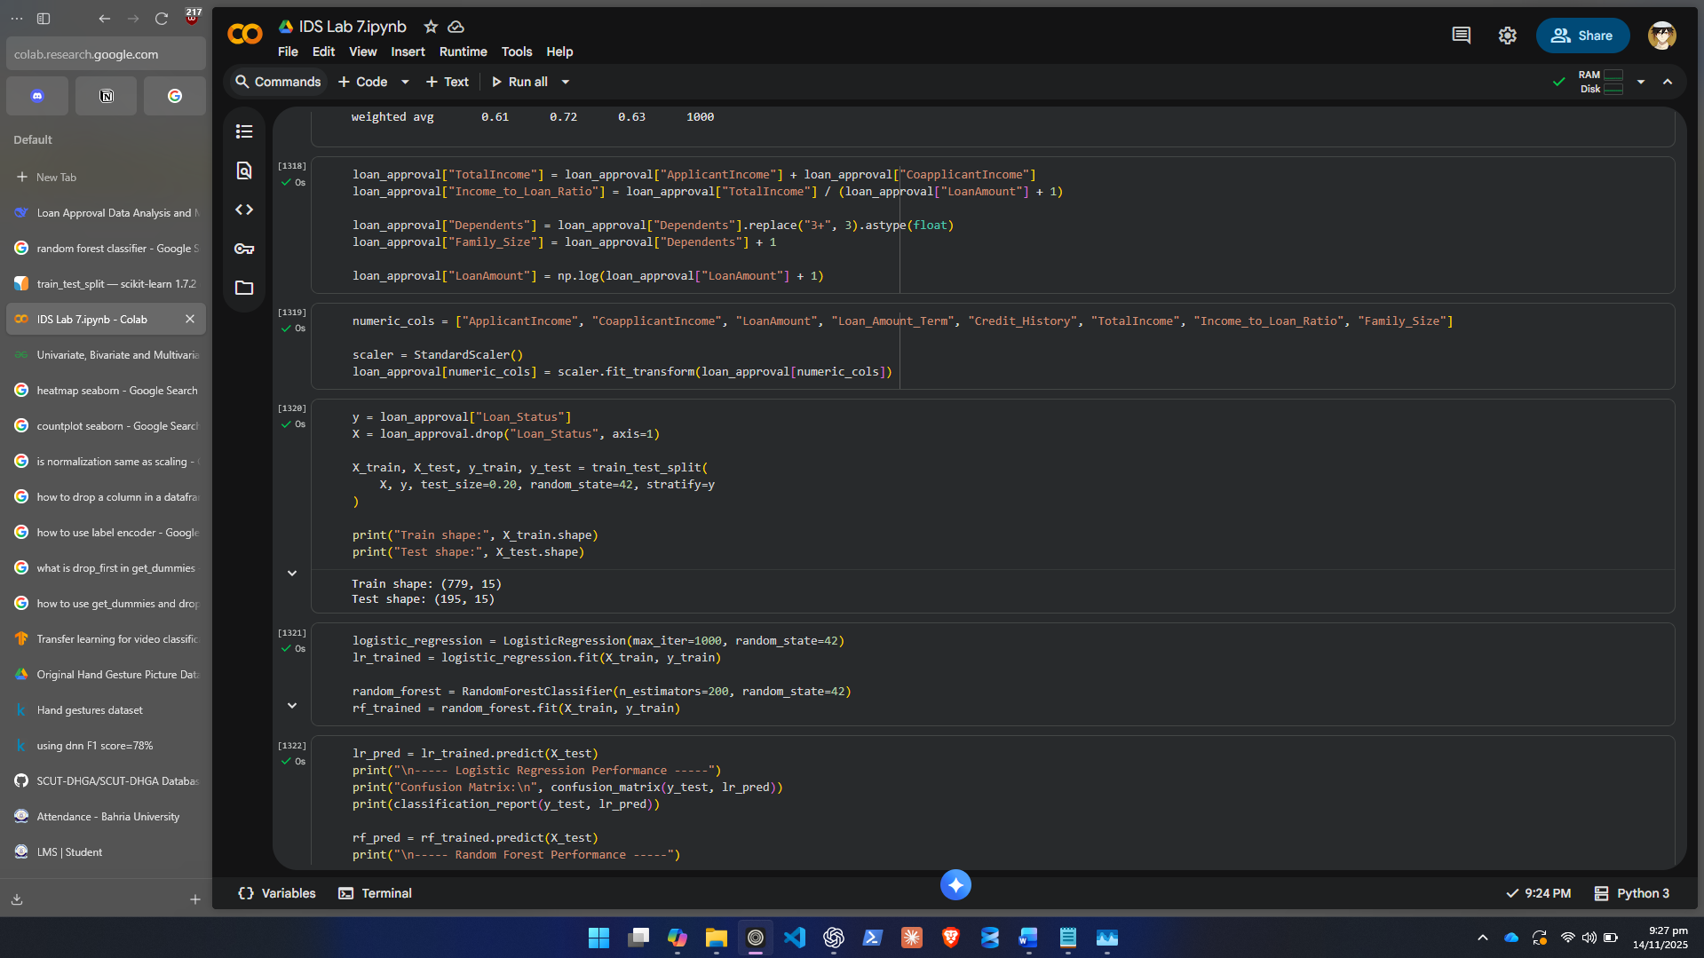

- Explain in your own words why each new feature might help the model.

- TotalIncome shows combined earning power.
- Income_to_Loan_Ratio measures ability to comfortably repay.
- Family_Size indicates financial responsibility load.
- Log_LoanAmount reduces skew and stabilizes the model.

Step 5: Data Splitting
- Split your dataset into Training (80%) and Testing (20%).
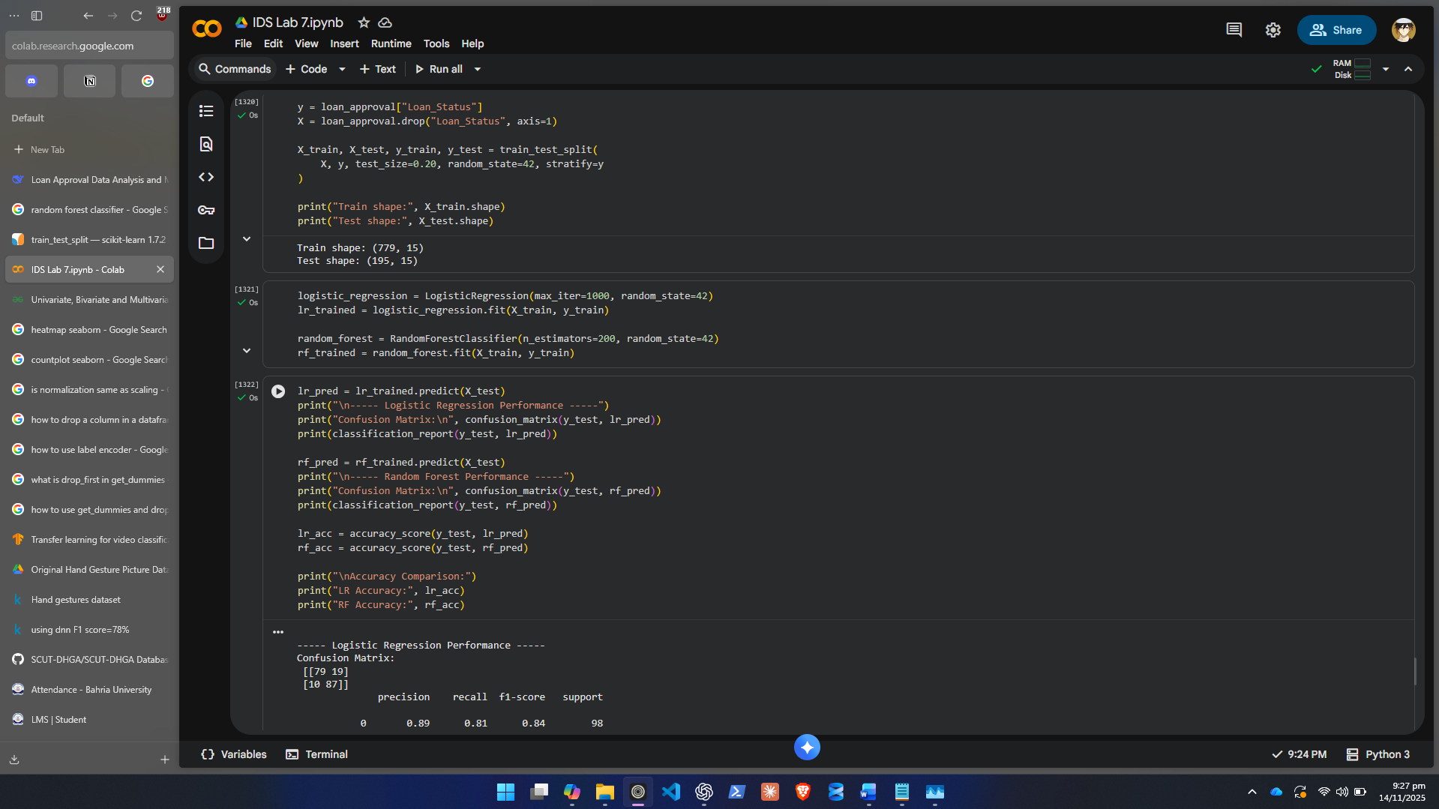
- Ensure that both classes (‘Y’ and ‘N’) are equally represented.
- Explain the reason for splitting and why we don’t train on all data.
We don’t train on all data in order to leave something for testing and validation so we can see if our trained model generalizes well on unseen data or not.

Step 6: Model Training
Train two classification models:
- Logistic Regression
  - Linear, interpretable model for binary classification.

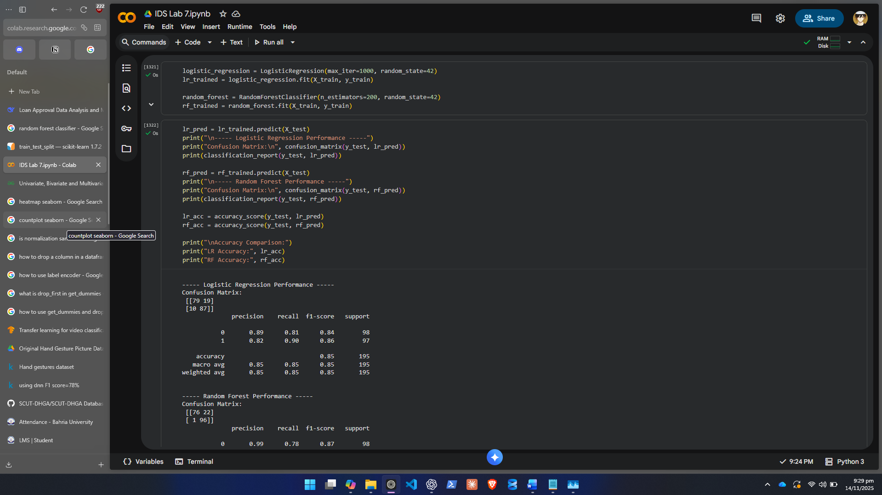
- Random Forest
  - Ensemble model that can capture non-linear patterns.
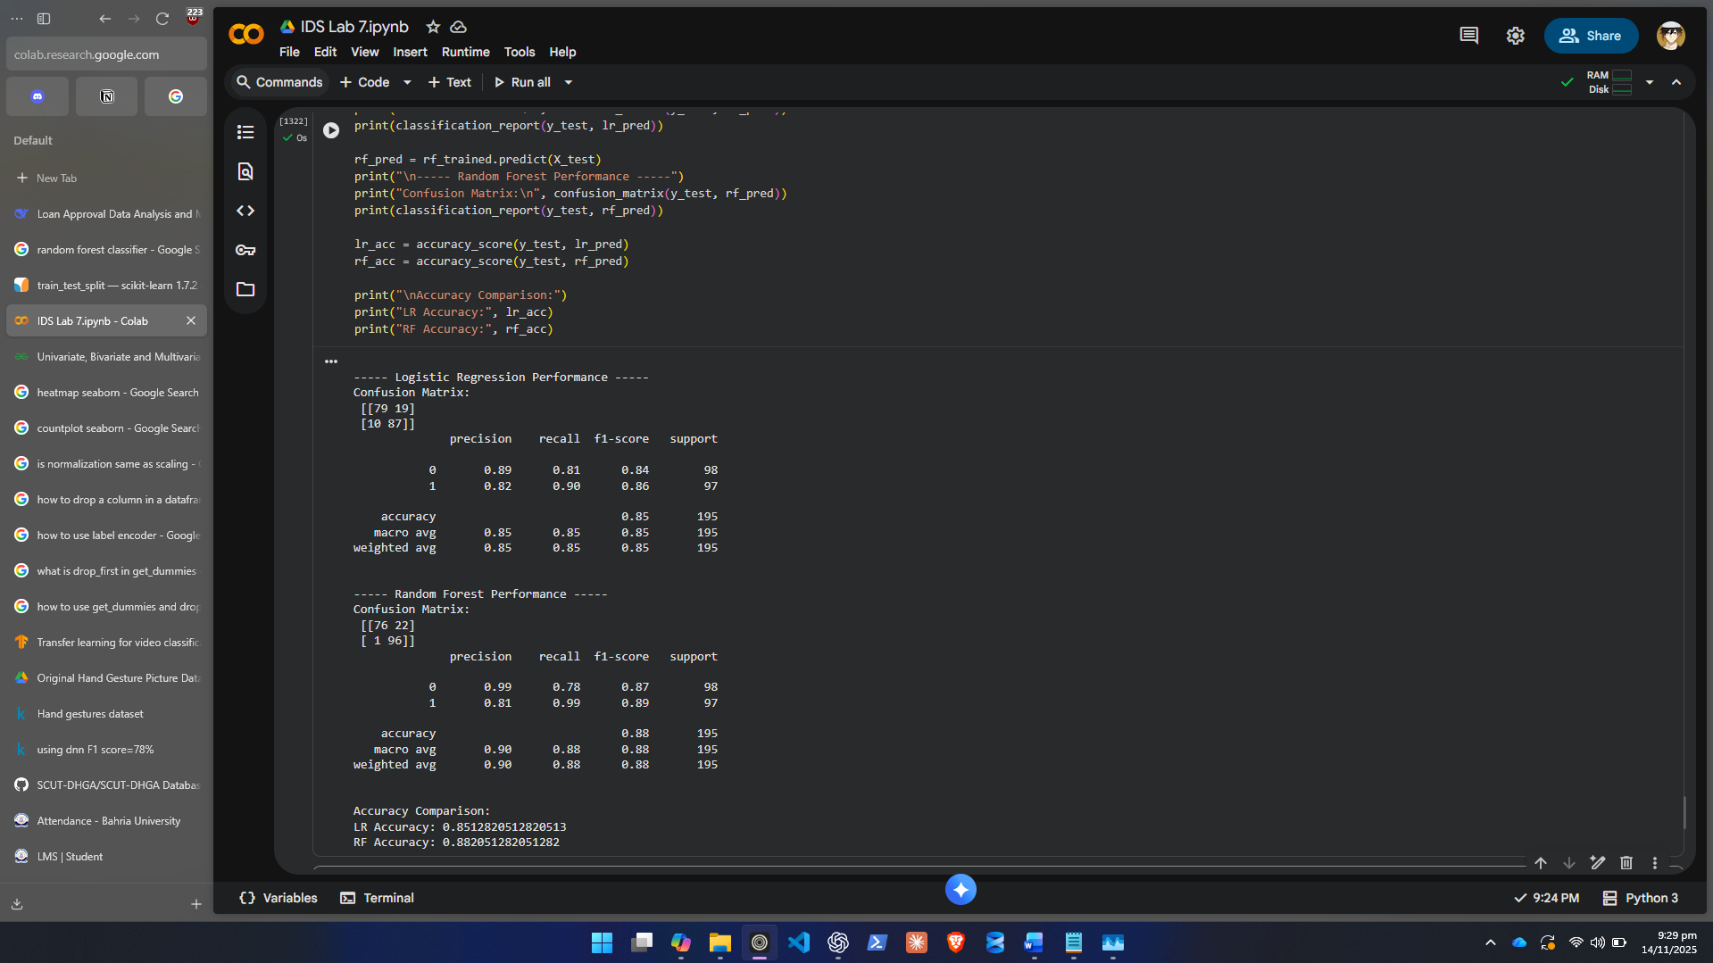
Describe conceptually:
- How each model learns from the training data.
Logistic Regression learns by finding the best-fitting linear boundary between the two classes. It uses a function called sigmoid to convert linear outputs into probabilities. Learning happens through gradient descent, where the model repeatedly adjusts weights to reduce prediction error. Random Forest creates multiple trees that might reuse data used in other trees and go in different directions to get different perspectives while building a prediction model. Each tree is trained on a different random subset of the data and features. Trees learn by splitting features into decision rules that separate the classes. The forest then averages the predictions of all trees to reduce noise and overfitting.

- Why Random Forest might perform better on this dataset.

Random Forest can amount for non-linear relationships.

Step 7: Model Evaluation
- Predict on the test set for both models.
- Evaluate using:
  - Accuracy
  - Precision
  - Recall
  - F1-score
  - Confusion Matrix
- Compare performance of both models and identify the better one.
Random Forest performs slightly better than logistic regression with better performance on classifying 1s. Actual People who were supposed to be approved are now approved more accurately.
- Interpret what the confusion matrix shows about model behavior.
In both models the classification of 0s is wrong about 25% of the time but classification of 1s is extremely better in Random Forest.
- Highlight whether your best model achieves above 80% accuracy.
Both models achieve better than 80% accuracy.

Step 8: Feature Importance and Interpretation
- For the Random Forest model, extract and visualize Feature Importance.
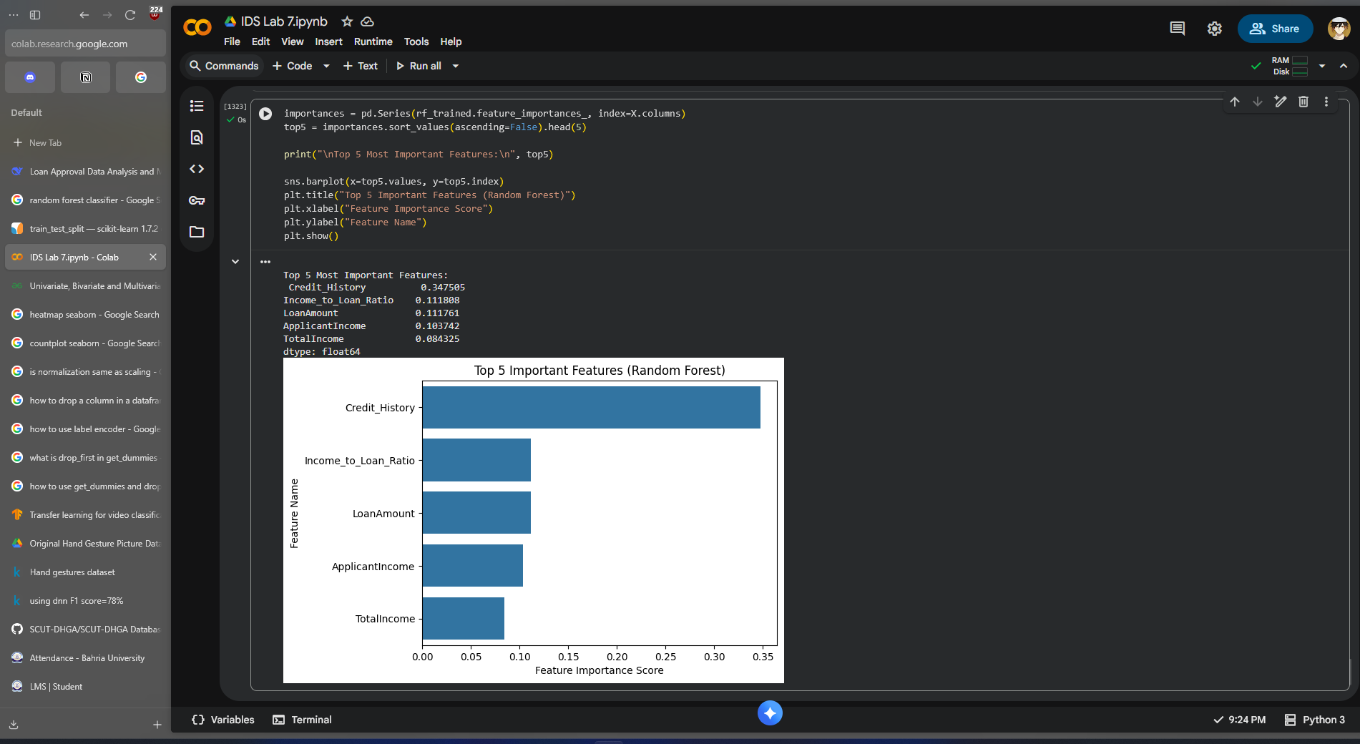
- Identify the top 5 most important features.
- Interpret what each top feature means in business terms, e.g.:
  - “Higher Credit History scores strongly increase approval likelihood.”
  - “Applicants with higher Income-to-Loan ratios are more likely to be approved.”

- Higher Credit_History more likely to approve loan.
- Higher Income_to_Loan_Ratio applicant can comfortably repay.
- Higher TotalIncome financially stronger applicant.
- Lower LoanAmount reduces lending risk.
- Family_Size indicates expense load; smaller size may mean more repayment ability.

Lab Grading Sheet:
Task | Max Marks | Obtained Marks | Comments(if any)
1. | 10
2. | 10
Total | 20 |  | Signature

Note : Attempt all tasks and get them checked by your Lab Instructor.

